PES UNIVERSITY
FACULTY OF ENGINEERING
Electronic City, Hosur Road, Bengaluru – 560 100, Karnataka, India

SMART CAMPUS EVENT MANAGEMENT SYSTEM

DBMS MINI PROJECT REPORT

Submitted in partial fulfilment of the requirements for the award of the degree of
Bachelor of Technology
in
Computer Science & Engineering

UE23CS351A – DBMS Project

Submitted by

Name | SRN
PRARTHANA HERUR | PES2UG24SCS367
POOJA KOPPAD | PES2UG24CS352

Academic Year 2026

CERTIFICATE

This is to certify that the mini project entitled “Smart Campus Event Management System” is a bonafide work carried out by the students listed below as part of the DBMS Project (UE23CS351A), in partial fulfilment of the requirements for the Bachelor of Technology programme in Computer Science & Engineering.

Student Name | SRN
PRARTHANA HERUR | PES2UG24SCS367
POOJA KOPPAD | PES2UG24CS352

The work presented in this report describes the design and implementation completed for the project, including the relational database setup, backend API development, frontend integration, and application workflow demonstrations.

DECLARATION

We hereby declare that the DBMS mini project entitled “Smart Campus Event Management System” is our work carried out as part of the DBMS Project (UE23CS351A). The implementation and documentation presented in this report are based on the work completed by our team. Any external tools, frameworks, libraries, and resources used in the project are acknowledged in the references.
We further declare that the report does not intentionally represent unfinished or unverified functionality as completed work.

Name | SRN
PRARTHANA HERUR | PES2UG24SCS367
POOJA KOPPAD | PES2UG24CS352

ACKNOWLEDGEMENT

We express our sincere gratitude to PES University and the Department of Computer Science & Engineering for providing the opportunity and resources to undertake this DBMS mini project.
We thank our faculty members for their academic guidance and for helping us strengthen our understanding of database design, relational modelling, SQL, backend development, and application integration.
We also acknowledge the developers and maintainers of the open-source technologies used in this project, including PostgreSQL, Prisma, Node.js, Express.js, Next.js, React, and Tailwind CSS.

ABSTRACT

The Smart Campus Event Management System is a web-based application designed to provide a centralized platform for discovering campus events, registering for events, managing event information, and collecting participant feedback. Campus event information is often communicated through multiple channels, which can make it difficult for students to find accurate event details and for organizers to manage registrations efficiently. The proposed system brings these activities together through a browser-based interface supported by a backend REST API and a relational database.
The application supports two principal user roles: students and organizers. Students can create an account, sign in, browse available events, register for events, view their registrations, and submit feedback. Organizers can sign in, create events, select a venue, specify event dates and times, set participant limits, and view events associated with their organizer account along with registration counts.
The backend is implemented using Node.js and Express.js. PostgreSQL is used as the primary relational database, and Prisma ORM provides database access through a defined schema and migration workflow. The frontend is developed using Next.js, React, TypeScript, and Tailwind CSS. Authentication uses JSON Web Tokens (JWT), while bcrypt is used for password hashing. Existing campus data was migrated from a MySQL source database to PostgreSQL while preserving record identifiers. The application therefore demonstrates relational database migration, authenticated API development, role-based workflows, and frontend-backend integration.
The implemented workflows were exercised using sample student and organizer accounts and sample event records. The report documents the system architecture, database design references, SQL database work, application structure, selected interface screenshots, and the completion status of the implemented features.

TABLE OF CONTENTS

- INTRODUCTION
- PROBLEM DEFINITION
- ER MODEL
- ER TO RELATIONAL MAPPING
- SQL DATABASE DESIGN AND COMMANDS
  - Database migration and setup
  - DDL and DML statements
  - Sample SQL verification commands
- BACKEND DEVELOPMENT
- FRONTEND DEVELOPMENT

7.5 PROJECT DIRECTORY STRUCTURE
smart-campus-event-management/
├── frontend/
│ ├── src/app/
│ │ ├── login/
│ │ ├── register/
│ │ ├── events/
│ │ ├── dashboard/
│ │ ├── my-registrations/
│ │ ├── feedback/
│ │ ├── feedback-list/
│ │ ├── organizer-dashboard/
│ │ ├── create-event/
│ │ └── registrations/
│ └── package.json
├── backend/
│ ├── prisma/
│ │ ├── schema.prisma
│ │ └── migrations/
│ ├── scripts/
│ │ └── migrate-mysql-to-postgres.js
│ ├── src/
│ │ ├── config/db.js
│ │ ├── routes/
│ │ │ ├── authRoutes.js
│ │ │ ├── eventRoutes.js
│ │ │ ├── venueRoutes.js
│ │ │ ├── registrationRoutes.js
│ │ │ └── feedbackRoutes.js
│ │ └── server.js
│ └── package.json
└── README.md
The tree above summarizes the application folders and route modules used in the implementation. It is a report-level view of the principal files rather than a listing of every configuration and generated file.

Student | Primary Work Areas | Evidence / Files
POOJA KOPPAD | MySQL database implementation and management; advanced SQL features including views, stored functions, stored procedures and triggers; MongoDB activity logging implementation and database integration; database testing and verification; organizer-side feature integration and workflow testing. | dbms_features.sql; backend/src/config/mongo.js; backend/src/utils/activityLogger.js; MySQL database objects and query outputs; MongoDB activity log records; organizer dashboard screenshots; Git commits.
PRARTHANA HERUR | PostgreSQL database setup and MySQL-to-PostgreSQL migration; Prisma schema configuration and migrations; backend API development using Node.js and Express; authentication, event management, venue, registration and feedback APIs; frontend integration using Next.js and TypeScript; MongoDB setup and activity logging; application testing and debugging. | backend/prisma/schema.prisma; backend/prisma/migrations/; backend/scripts/migrate-mysql-to-postgres.js; backend/src/config/db.js; backend/src/config/mongo.js; backend/src/utils/activityLogger.js; backend/src/routes/; backend/src/server.js; frontend/src/app/; Git commits; application screenshots.

  - Project directory structure
  - MongoDB / NoSQL database implementation
  - Advanced SQL features
  - Organizer features and interface
  - Team contribution summary
- APPLICATION WORKFLOW AND SCREENSHOTS
- EVALUATION RUBRICS – COMPLETION STATUS

INTRODUCTION
Campus events include technical workshops, cultural programmes, seminars, club activities, and other student engagements. Managing these events involves maintaining event details, venue information, organizer information, participant limits, registrations, and feedback. When these activities are handled independently, students may find it difficult to locate current event information and organizers may need to maintain registration details manually.
The Smart Campus Event Management System addresses this problem through a centralized web application. It provides a common interface for students and organizers and stores the core information in a relational database. The system separates presentation, application logic, and persistent data storage.

Objectives
- Provide a centralized listing of campus events and their details.
- Allow students to register and view their own event registrations.
- Allow organizers to create events with venue, date, time, and participant-limit information.
- Maintain relational records for students, organizers, venues, events, registrations, and feedback.
- Use authenticated API requests and role-based authorization for protected operations.
- Demonstrate migration of existing MySQL data into PostgreSQL.

Scope
The implemented scope documented in this report covers student and organizer authentication, public event browsing, venue retrieval, event creation by organizers, student event registration, viewing personal registrations, and feedback submission and listing. The report limits its claims to workflows and database work that were implemented and exercised.

Users and roles
Role | Responsibilities supported by the application
Student | Register, log in, browse events, register for events, view own registrations, and submit feedback.
Organizer | Log in, create events, choose a venue, define event timing and capacity, and view organizer-owned events with  registration counts.

PROBLEM DEFINITION
The problem addressed is the lack of a single, structured platform for managing campus event information and student participation. Event details, venue allocation, registration information, and participant feedback are related data items. If these records are maintained separately, data duplication and inconsistent updates can occur.

Existing challenges
- Students may need to check multiple communication channels to discover events.
- Organizers need a consistent way to publish event details and define participant limits.
- Registration records must be associated with both the student and the selected event.
- Venue capacity and event capacity need to be considered when an organizer creates an event.
- Feedback should be associated with the event and the student who submitted it.

Proposed solution
The proposed system uses a Next.js frontend to present role-specific screens, an Express.js backend to expose REST endpoints, and PostgreSQL to persist relational data. Prisma ORM maps application models to the existing relational tables. JWT-based authentication identifies the current user, and backend authorization checks restrict student and organizer operations to the appropriate role.

Functional requirements
ID | Requirement | Implemented behaviour
FR1 | User authentication | Student registration and login; organizer login.
FR2 | Event discovery | Public event listing with organizer  and venue details.
FR3 | Venue retrieval | API returns available venue records.
FR4 | Event creation | Authenticated organizers create  events with venue, date, time, and capacity.
FR5 | Event registration | Authenticated students register subject to duplicate and capacity checks.
FR6 | Registration history | Students view their own registrations.
FR7 | Feedback | Students submit feedback; feedback can be listed with student and event details.

ER MODEL
The database design is organized around six principal entities: Student, Organizer, Venue, Event, Registration, and Feedback. These entities represent the main participants and records required for campus event management.

Entity | Purpose
STUDENT | Stores student account and profile information.
ORGANIZER | Stores organizer account information.
VENUE | Stores venue details and capacity information.
EVENT | Stores event details and links an event to its organizer and venue.
REGISTRATION | Associates a student with an event and stores registration information.
FEEDBACK | Stores a student's rating and comments associated with an event.

The ER diagram prepared for the project should be inserted in this section. The diagram should clearly show primary keys, foreign-key relationships, and relationship cardinalities.

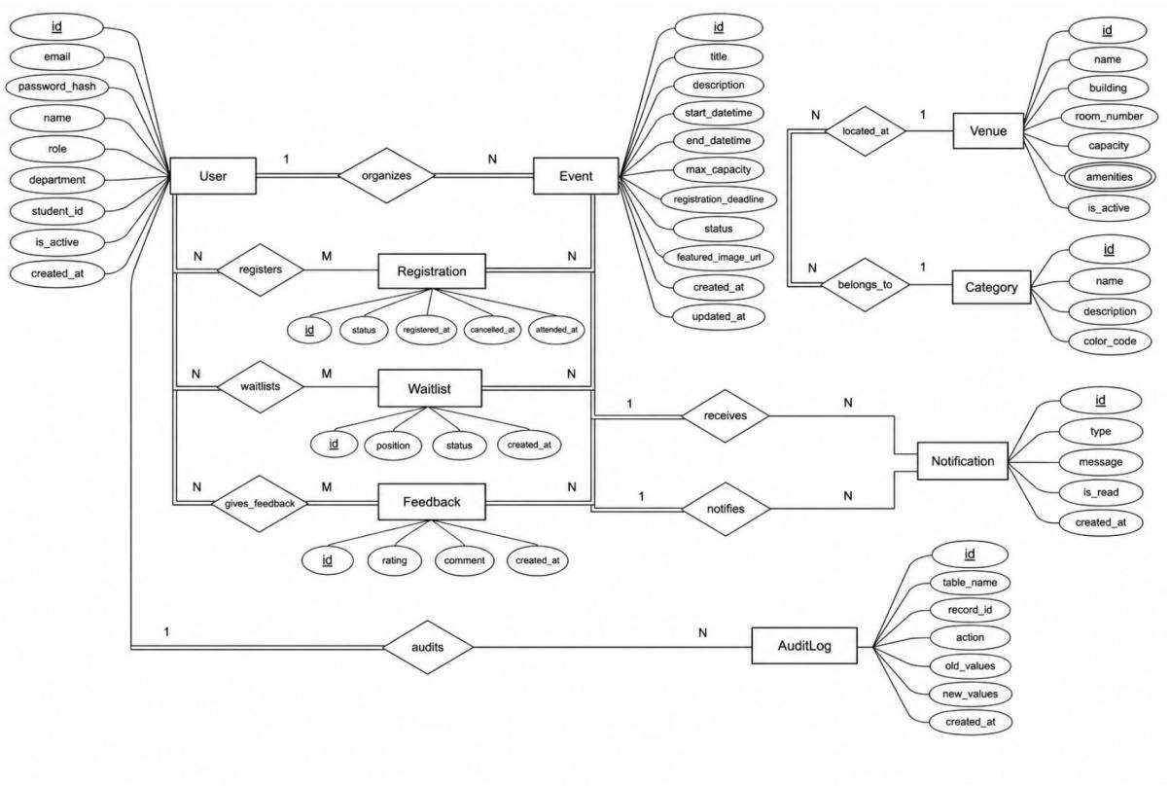
Figure 3.1: Entity–Relationship diagram of the Smart Campus Event Management System.

ER TO RELATIONAL MAPPING
The ER model is mapped to a relational design using relations for Student, Organizer, Venue, Event, Registration, and Feedback. Each entity is represented by a table. Primary keys uniquely identify records, while foreign keys maintain relationships between related tables.

Mapping of entities and relationships
ER component | Relational representation
Student entity | STUDENT relation with a student identifier as its primary key.
Organizer entity | ORGANIZER relation with an organizer identifier as its  primary key.
Venue entity | VENUE relation with a venue identifier as its primary key.
Event entity | EVENT relation; references the organizer and venue  associated with the event.
Student–Event registration | REGISTRATION relation; references the student and event, representing their participation association.
Feedback | FEEDBACK relation; references the student and event for which feedback is submitted.

Relational schema
The final relational schema prepared by the project team should be inserted here without changing its attribute names or key notation. The schema should identify each relation's primary key and all foreign-key constraints.
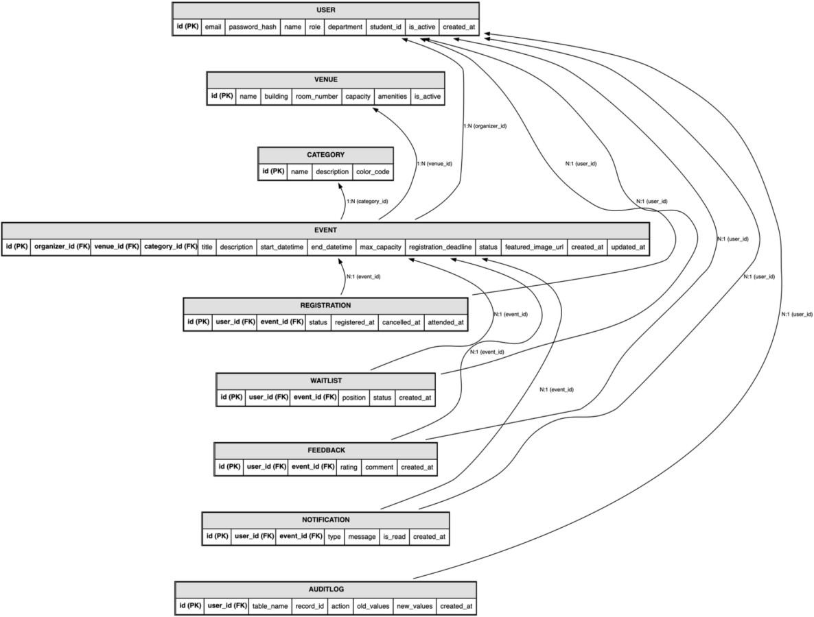

Figure 4.1: Relational schema derived from the ER model.

Referential integrity
Foreign-key relationships ensure that an event refers to a valid organizer and venue, a registration refers to a valid student and event, and feedback refers to valid student and event records. These relationships help preserve consistency across the database.

SQL DATABASE DESIGN AND COMMANDS
PostgreSQL is the primary relational database used by the application. The project began with an existing MySQL database named smart_campus_db. The data was migrated into a PostgreSQL database with the same logical database name. The migration preserved the identifiers of the existing records so that relationships between students, organizers, venues, events, registrations, and feedback remained consistent.

Database migration and setup
The migration was performed using a Node.js migration script located in backend/scripts/migrate-mysql-to-postgres.js. The script transfers the records from the MySQL source database to PostgreSQL. The original MySQL database was retained and not deleted.

Database | Purpose | Status
MySQL 8.0.46 | Original source database containing the initial project records. | Retained as source.
PostgreSQL 17.11 | Primary database used by the  backend application. | Configured and populated.
Prisma ORM 6.19.3 | Schema mapping and database migration tooling. | Configured; schema validation and initial migration completed.

The initial record counts were checked after migration. The six application tables contained the same number of records in both databases.

Table | MySQL records | PostgreSQL records
STUDENT | 6 | 6
ORGANIZER | 2 | 2
VENUE | 3 | 3
EVENT | 3 | 3
REGISTRATION | 5 | 5
FEEDBACK | 2 | 2
Total | 21 | 21

DDL and DML statements
The Data Definition Language (DDL) statements prepared for the project define the six relational tables, their columns, primary keys, foreign keys, and integrity constraints. The Data Manipulation Language (DML) statements insert and maintain the sample records used to test the application.
The completed DDL and DML command sets prepared by the team should be included in this subsection exactly as executed. The report does not recreate or rename the attributes from the team's approved relational schema.

DDL statements

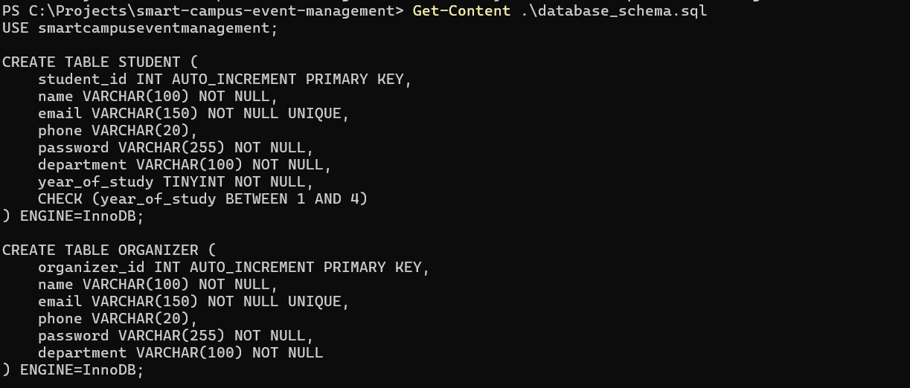
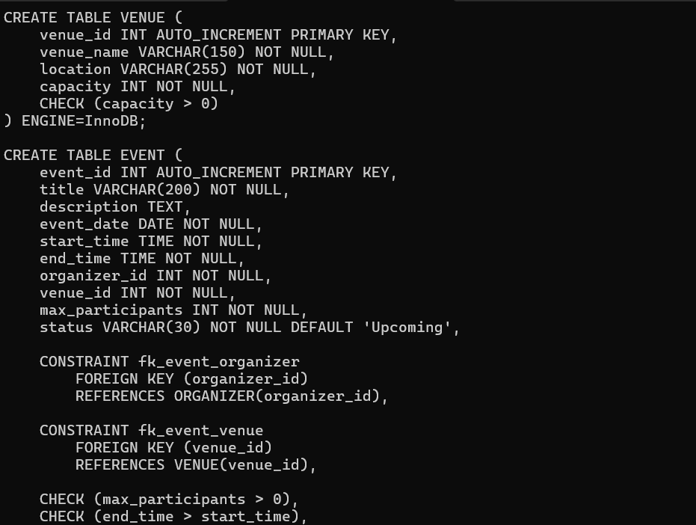

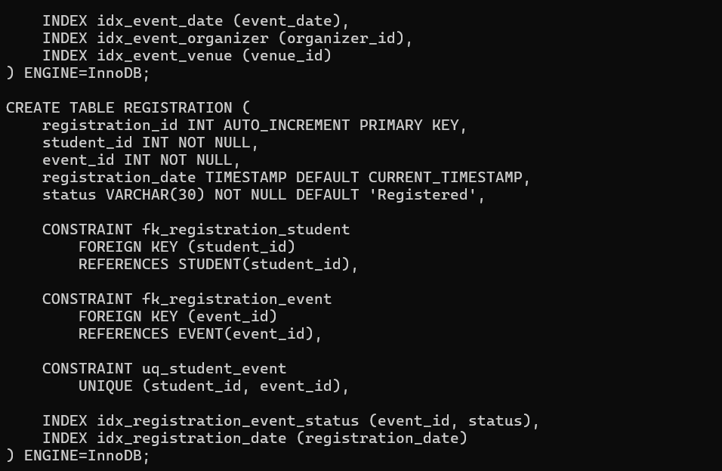

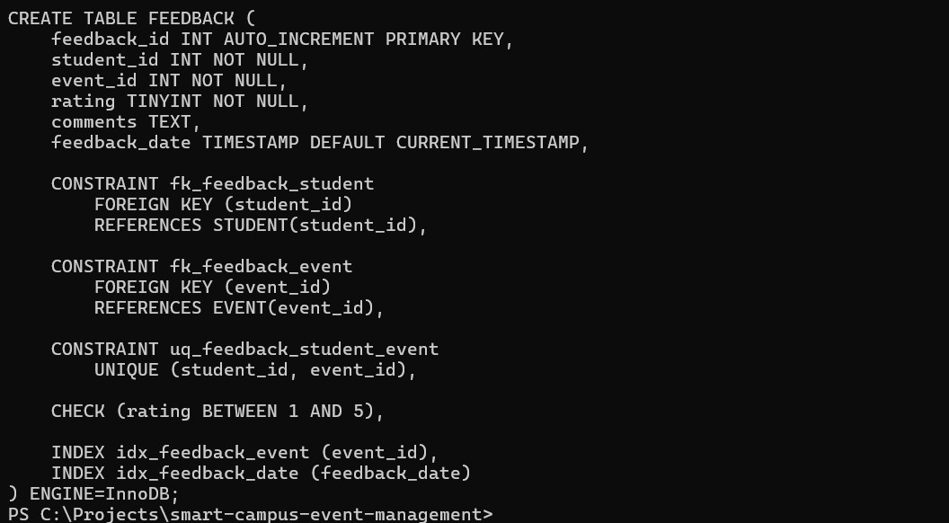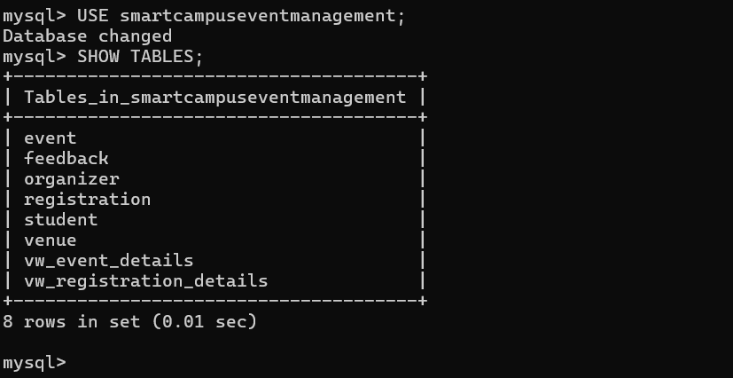

DML statements
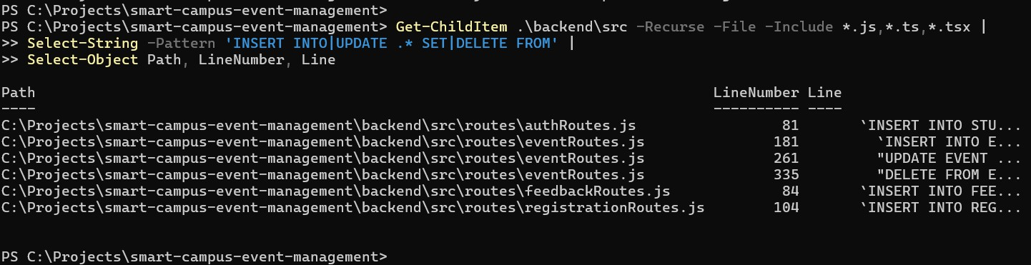

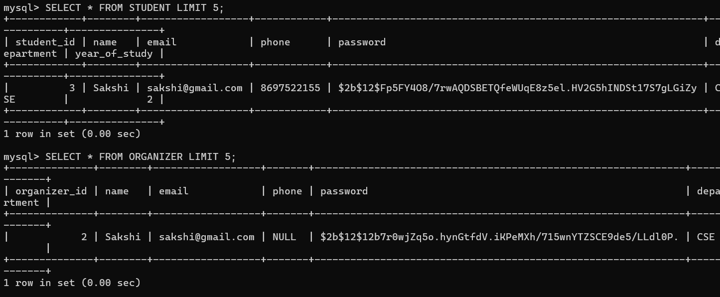
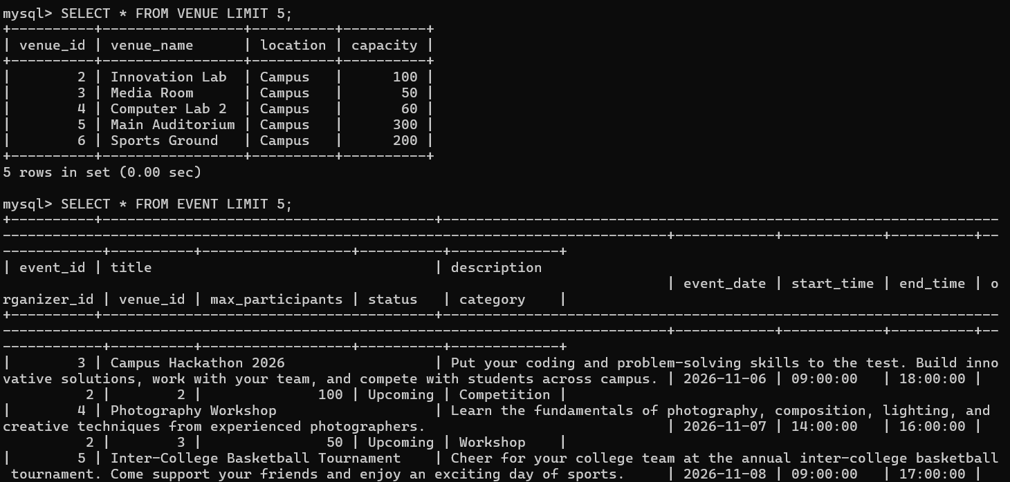
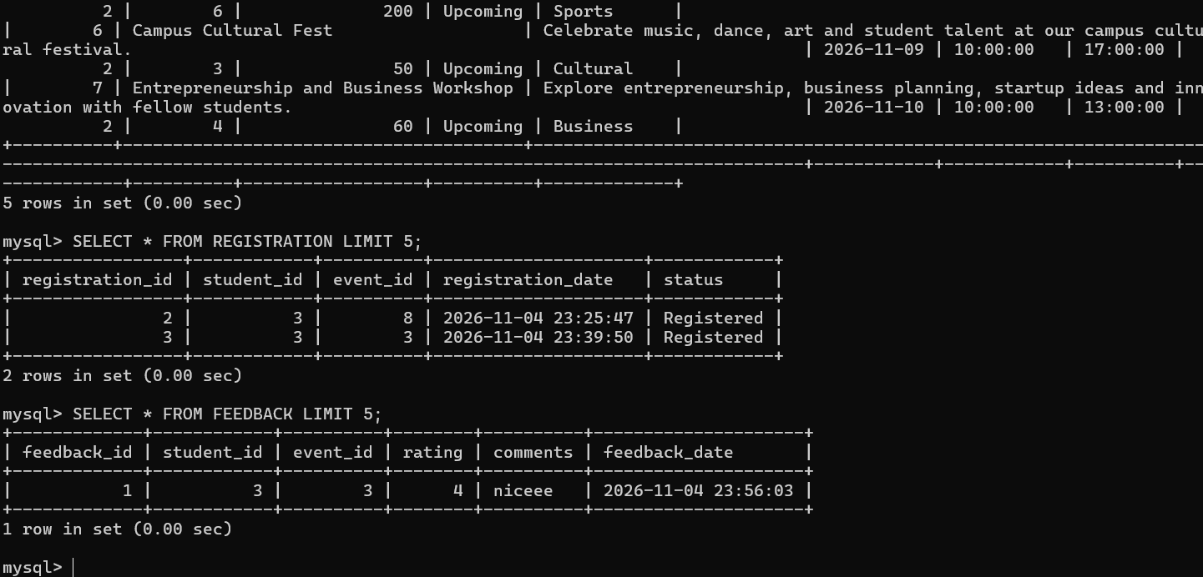

Sample SQL verification commands
The following read-only PostgreSQL queries can be used to verify the migrated records and inspect the database during demonstration.
SELECT COUNT(*) FROM STUDENT;\nSELECT COUNT(*) FROM ORGANIZER;\nSELECT COUNT(*) FROM VENUE;\nSELECT COUNT(*) FROM EVENT;\nSELECT COUNT(*) FROM REGISTRATION;\nSELECT COUNT(*) FROM FEEDBACK;
The following query displays the event records together with their venue and organizer identifiers. It is a simple verification query and does not modify database contents.
SELECT event_id, title, organizer_id, venue_id, event_date\nFROM EVENT\nORDER BY event_id;
The following query checks registration records and the identifiers that connect them to students and events.
SELECT * FROM REGISTRATION;

Prisma schema and migration
Prisma is used as the Object–Relational Mapper (ORM) between the Express backend and PostgreSQL. The Prisma schema maps the six application models to the existing uppercase table names. Field mappings preserve the database's column naming convention. The initial Prisma migration was generated and applied, and schema validation completed successfully.
The Event model uses a date field for the event date and time fields for the start and end times. The backend uses a shared Prisma client module so route handlers can access the PostgreSQL database through a consistent connection.

BACKEND DEVELOPMENT
The backend is implemented using Node.js and Express.js. It exposes REST API endpoints consumed by the Next.js frontend. The server mounts route modules for authentication, events, venues, registrations, and feedback.

Backend modules
Module | Responsibility
server.js | Initializes the Express application and mounts API route modules.
config/db.js | Creates and exports the shared Prisma client.
auth routes | Handles student registration and login, organizer login, password verification, and JWT issuance.
event routes | Returns public event data, creates events for authorized  organizers, and retrieves events belonging to the logged-in organizer.
venue routes | Returns venue information for event creation.
registration routes | Creates student registrations and retrieves a student's own registrations or organizer registration information.
feedback routes | Accepts student feedback and returns feedback with  related student and event information.

Authentication and authorization
Passwords are hashed using bcrypt rather than being stored as plain text. On successful login, the backend issues a JSON Web Token (JWT). Protected routes use the token to identify the user and enforce role

restrictions. Student-only operations include event registration, personal registration history, and feedback submission. Event creation and organizer event listing are restricted to authenticated organizers.

Registration validation
The registration endpoint checks whether the event exists and is not cancelled, whether the event has remaining capacity, and whether the student has already registered. The operation uses a database transaction and a row-level lock on the event record while checking and creating a registration. A duplicate registration is handled as a conflict rather than creating a second registration.

API endpoint summary
HTTP method | Endpoint | Purpose / access
POST | /api/auth/register | Create a student account.
POST | /api/auth/login | Authenticate a student or organizer and return a token.
GET | /api/events | Public event listing.
POST | /api/events | Create an event; organizer access.
GET | /api/events/mine | Retrieve events belonging to the logged-in organizer.
GET | /api/venues | Retrieve venues.
POST | /api/registrations | Register the logged-in student for an event.
GET | /api/registrations/my | Retrieve registrations of the logged-in  student.
GET | /api/registrations | Organizer registration listing; organizer access.
GET | /api/feedback | Retrieve feedback records.
POST | /api/feedback | Submit feedback; student access.

FRONTEND DEVELOPMENT
The frontend is developed using Next.js 16.3.8, React 19.2.8, TypeScript, and Tailwind CSS. The interface communicates with the Express backend through HTTP requests. The frontend API base URL is configured using the NEXT_PUBLIC_API_URL environment variable. Authentication information is maintained in session storage for the active browser session.

Main application pages
Page / route | Purpose
/login | Sign in for students and organizers.
/register | Create a student account.
/events | Browse campus events.
/events/[id] | View event details and initiate registration.
/dashboard | Student dashboard.
/my-registrations | View the logged-in student's registrations.
/feedback | Submit event feedback.
/feedback-list | View submitted feedback.
/organizer-dashboard | View events created by the logged-in organizer and registration counts.
/create-event | Create an event with venue, date, time, and capacity.
/registrations | Organizer registration view.

Student workflow
A student creates an account or signs in, opens the public events page, selects an event, and submits a registration. The student can then open My Registrations to review their registrations. The feedback page allows the student to select an event and submit a rating and comments.

Organizer workflow
An organizer signs in and opens the organizer dashboard. The dashboard retrieves events associated with the organizer's authenticated account and displays registration counts. The organizer can use Create Event to enter the event title, description, date, start and end times, venue, and maximum participant count.

Frontend and backend integration
The frontend sends API requests to the backend using the configured API base URL. Protected requests include the JWT in the Authorization header. The backend remains responsible for validating the token, checking the user's role, enforcing business rules, and reading or writing PostgreSQL records.

PROJECT DIRECTORY STRUCTURE
smart-campus-event-management/\n
├── frontend/\n
│ ├── src/app/\n
│ │ ├── login/\n
│ │ ├── register/\n
│ │ ├── events/\n
│ │ ├── dashboard/\n
│ │ ├── my-registrations/\n
│ │ ├── feedback/\n
│ │ ├── feedback-list/\n
│ │ ├── organizer-dashboard/\n
│ │ ├── create-event/\n
│ │ └── registrations/\n
│ └── package.json\n
├── backend/\n
│ ├── prisma/schema.prisma\n
│ ├── scripts/migrate-mysql-to-postgres.js\n
│ ├── src/config/db.js\n
│ ├── src/routes/\n
│ └── src/server.js\n
└── README.md

NOSQL DATABASE IMPLEMENTATION – MONGODB

Purpose of MongoDB in the Project
MongoDB was integrated into the Smart Campus Event Management System to store application activity logs. MySQL stores structured relational data, including students, organizers, events,

registrations, and feedback, while MongoDB provides document-based storage for selected application activities.
Activity logs support monitoring, debugging, and tracking application operations without adding logging records to the primary relational tables.
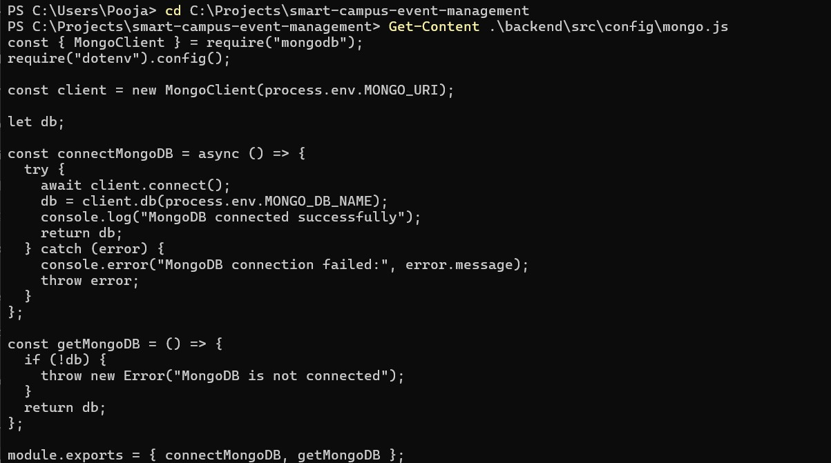

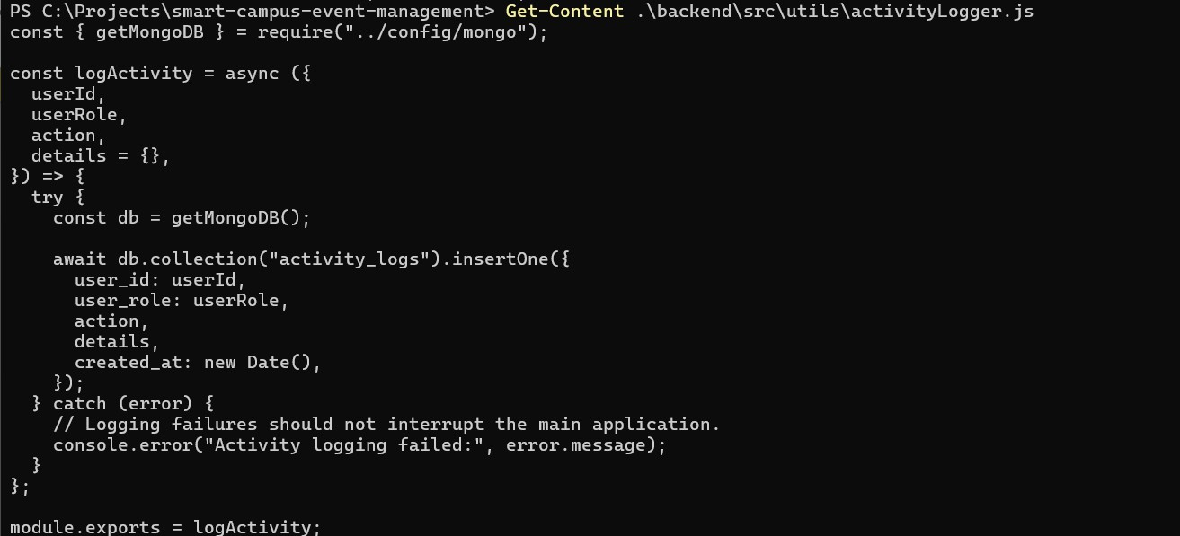

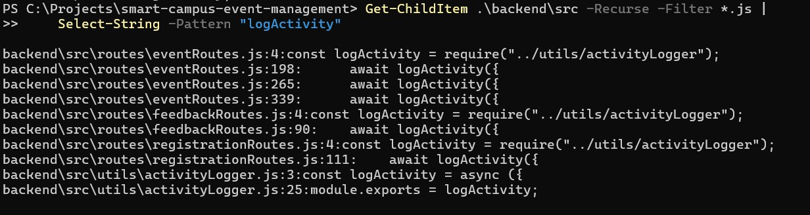

MongoDB Setup and Connection
MongoDB was integrated into the backend using the official MongoDB Node.js driver.
A separate configuration file, backend/src/config/mongo.js, was created to establish and manage the MongoDB connection.
The connection details are maintained using environment variables rather than hardcoding database credentials in the source code.
The MongoDB database used in the project is named smart_campus_logs. The configuration provides two main functions:
      - connectMongoDB() establishes a connection with the MongoDB server and selects the configured database.
      - getMongoDB() provides access to the connected database for other backend modules.
This approach keeps the database connection logic separate from the application routes and makes it easier to reuse the connection throughout the backend.
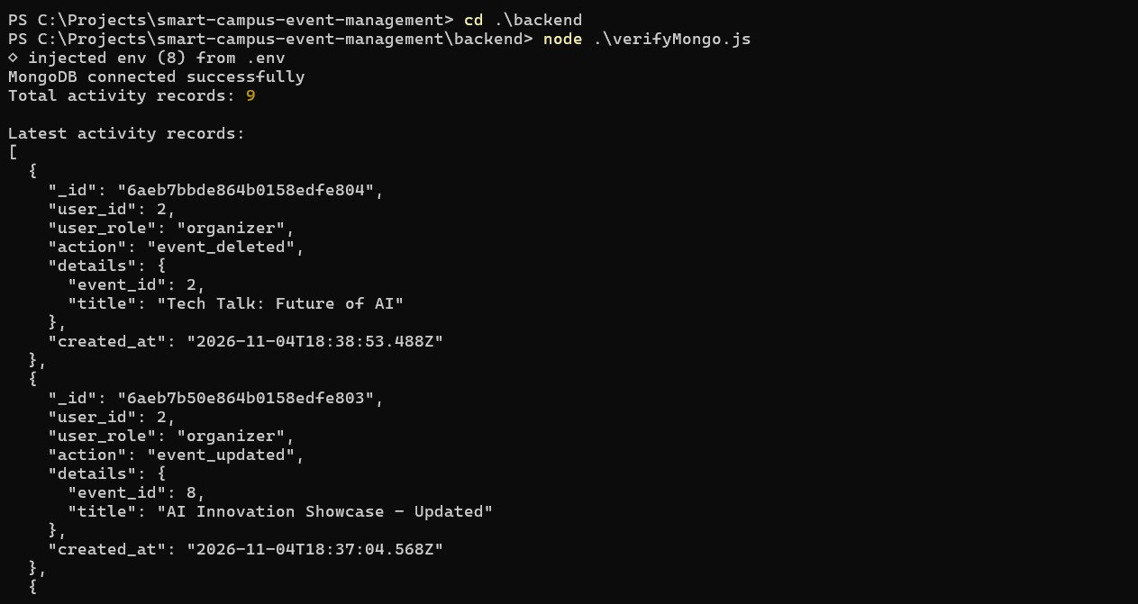

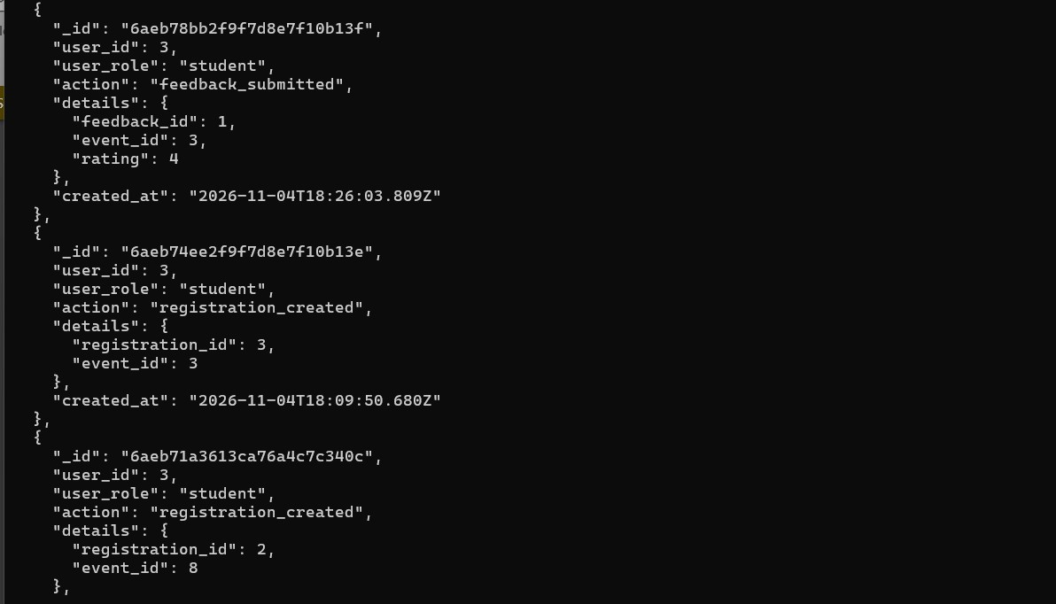
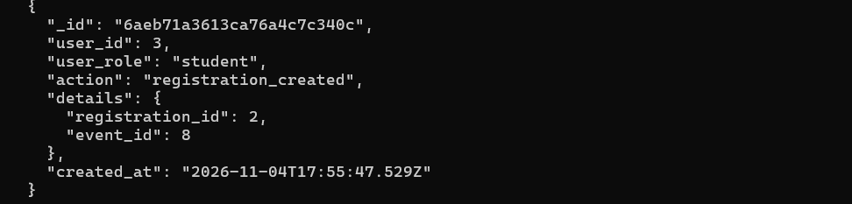
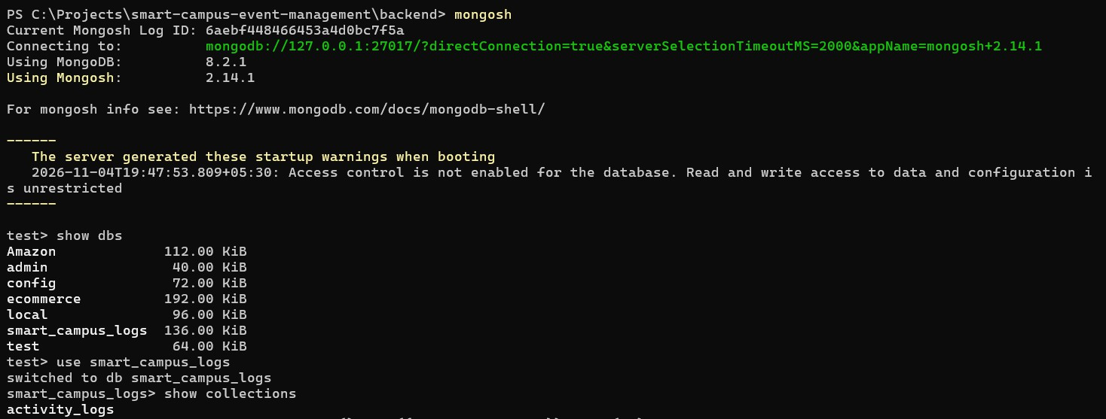

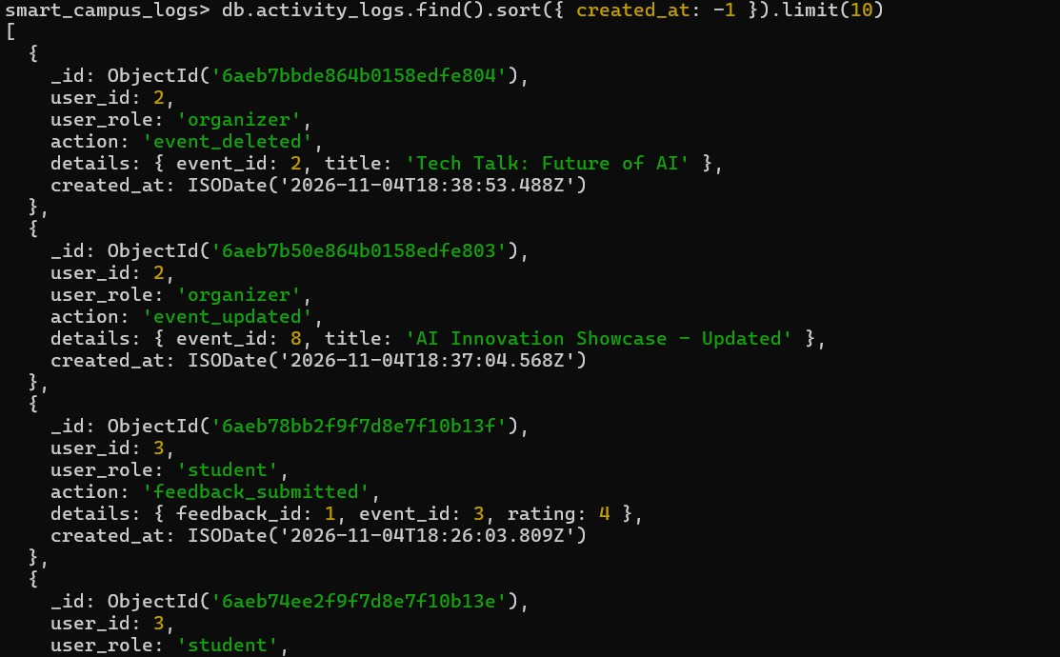
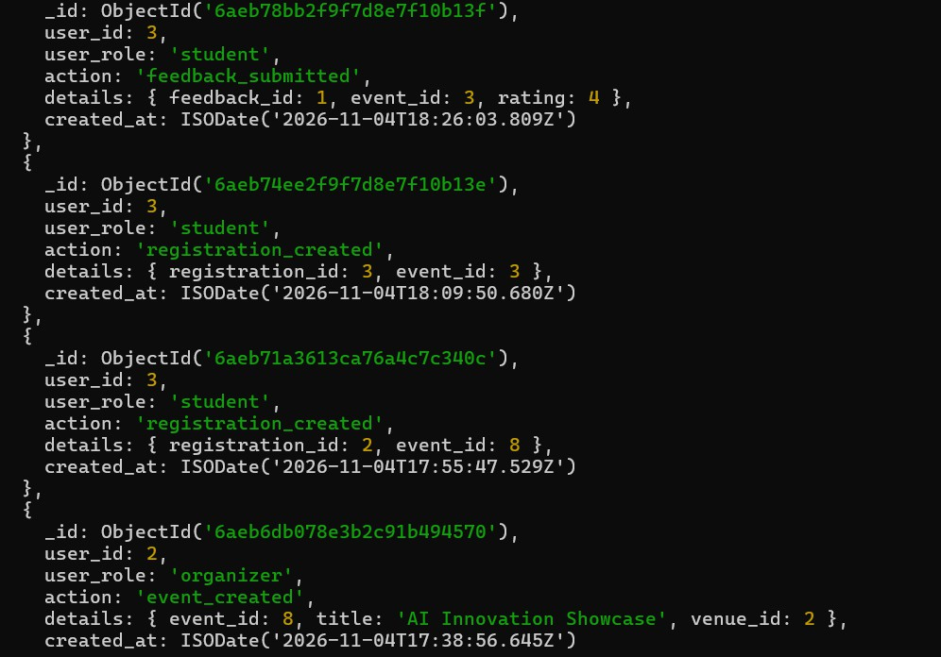

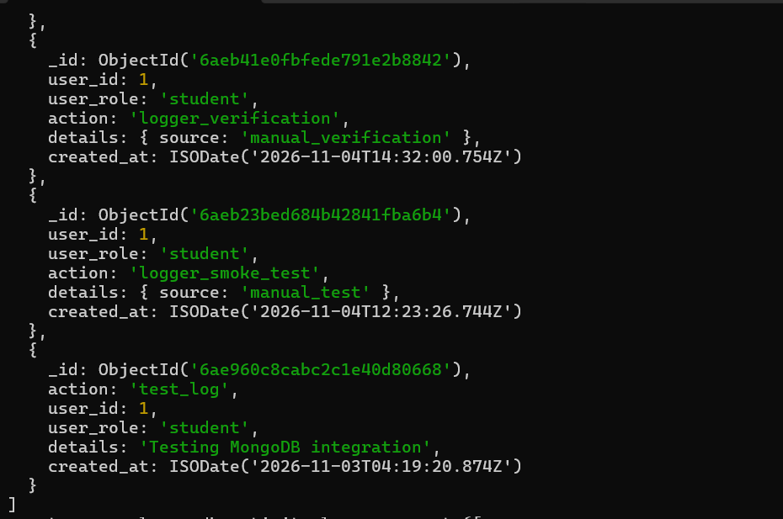

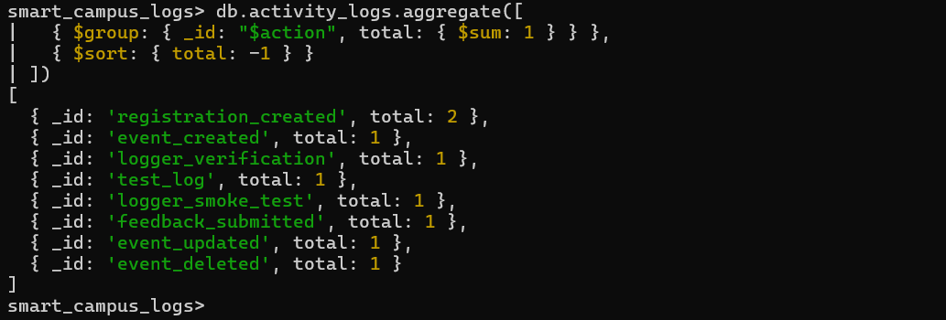

Document Design and Sample Documents
Each activity log is stored as a MongoDB document with the following fields:

Field | Description
user_id | Identifier of the user associated with the activity
user_role | Role of the user performing the activity
action | Name of the recorded action

details | Additional information about the activity
created_at | Timestamp when the activity was recorded
Example document:
{
"user_id": 1, "user_role": "organizer",
"action": "logger_verification", "details": {
"source": "manual_verification"
},
"created_at": "2026-11-04T14:32:00.754Z"
}
The example represents a verification record. Actual application records depend on the operations integrated with the activity logger.
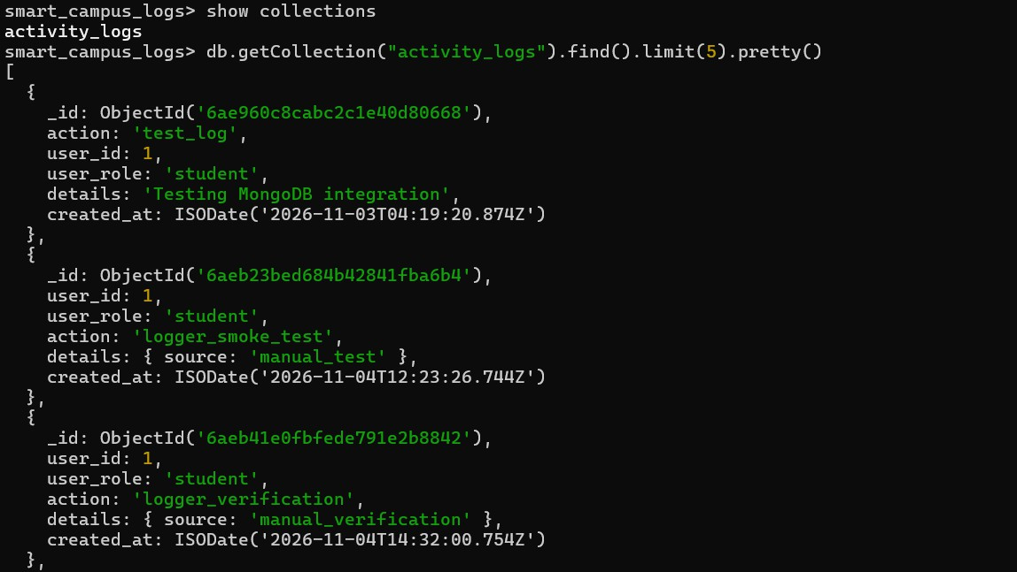

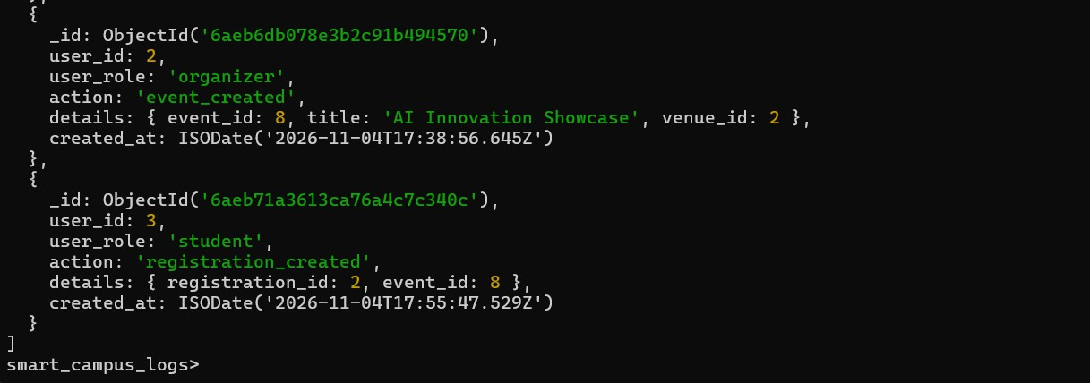

MongoDB Commands
The following commands can be used to inspect the activity collection: show dbs
use < smart_campus_logs > show collections

db.activity_logs.find().pretty()

db.activity_logs.find().sort({ created_at: -1 })

db.activity_logs.countDocuments({})

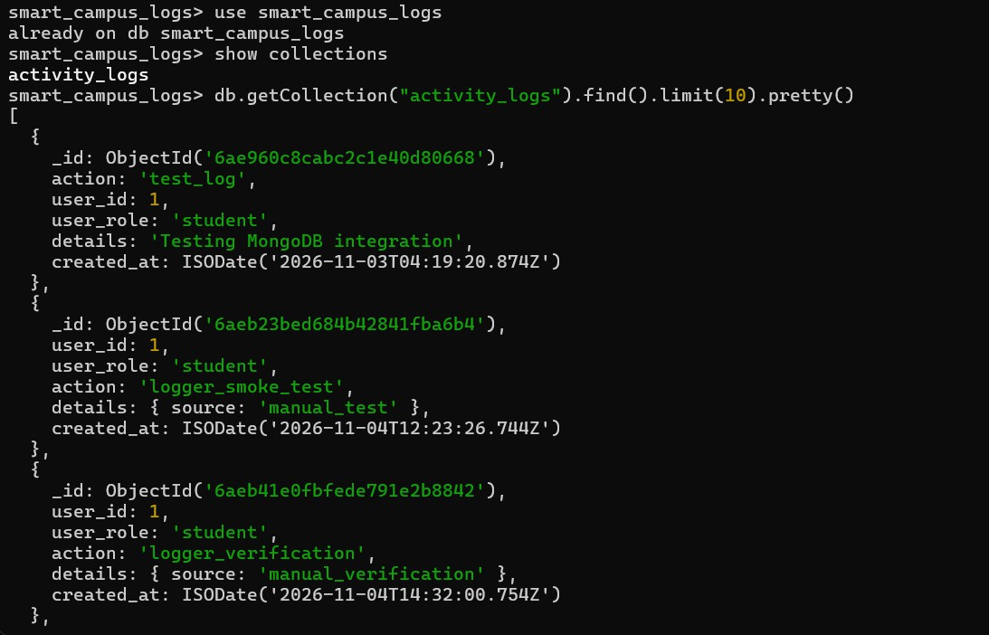
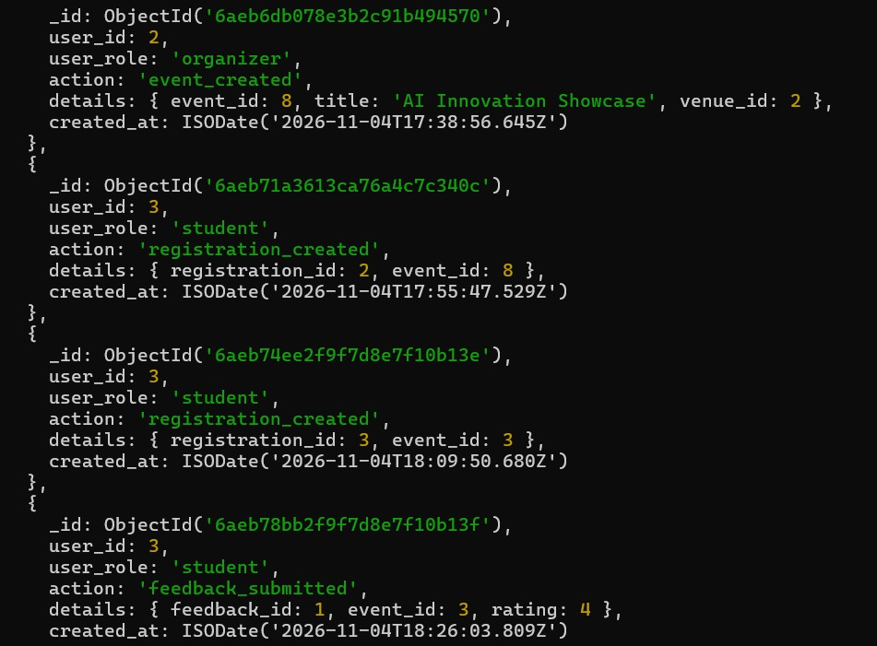

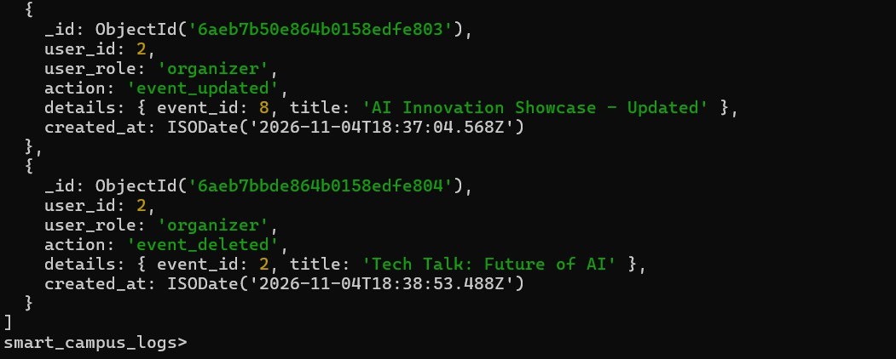

Activity Logging Implementation
The reusable activity logging utility inserts documents into the activity_logs collection using the MongoDB driver's insertOne() operation.
The utility records the user identifier, user role, action, additional details, and creation timestamp. Logging errors are caught so that a logging failure does not interrupt the main application operation.
The logger is integrated into selected backend operations. Authentication routes do not currently use this activity logger.
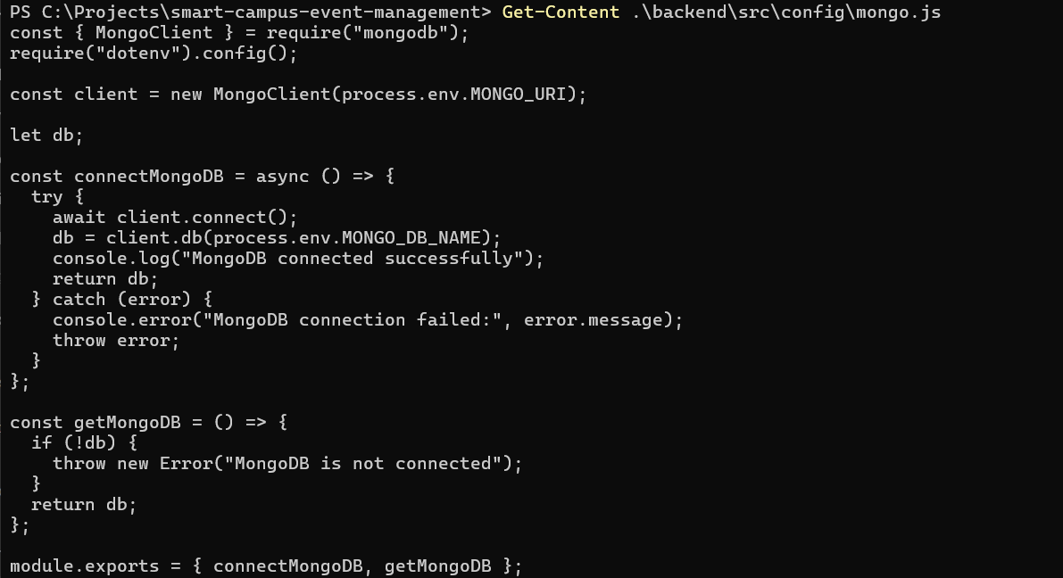

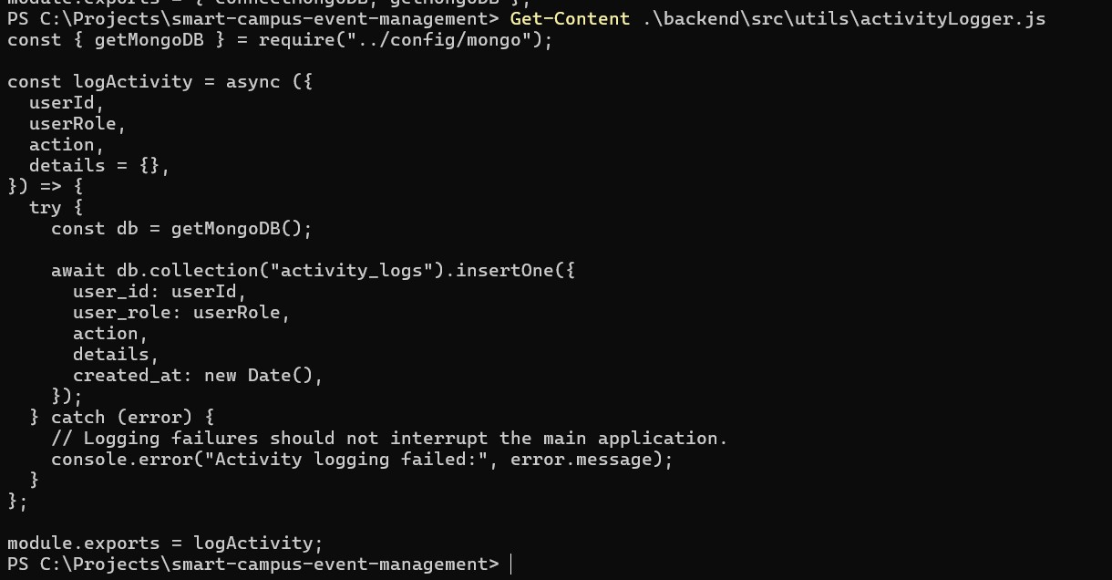

Aggregation and Query Results
The following aggregation groups activity records by action and counts the number of occurrences: db.activity_logs.aggregate([
{
$group: {
_id: "$action", total: { $sum: 1 }
}
},
{
$sort: { total: -1 }
}
])
The $group stage groups documents by their action, $sum counts records in each group, and $sort orders the results by descending count.

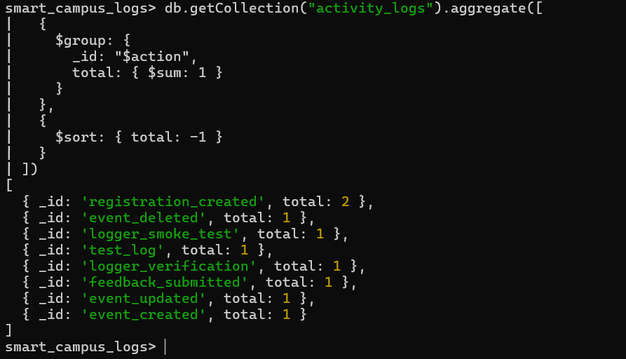

MySQL and MongoDB Responsibilities
MySQL is the primary relational database for structured application data and transactional relationships. MongoDB stores activity-log documents that can contain flexible details about selected application operations.
The two databases serve complementary purposes: MySQL maintains the application's relational records and constraints, while MongoDB supports activity monitoring and debugging.
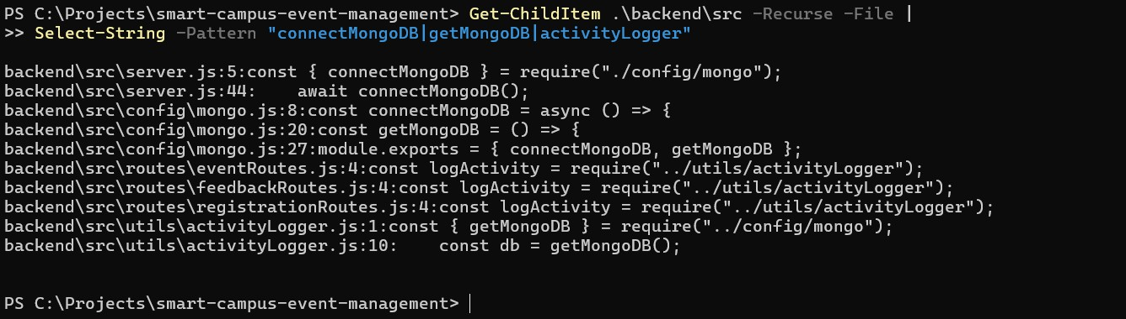

MongoDB Testing and Completion Evidence
MongoDB integration was verified by connecting to the database, inserting a verification activity record, and retrieving the stored document.

Test | Expected result | Status
Establish MongoDB connection | Successful connection | Passed

Insert verification activity | Document inserted | Passed
Retrieve activity record | Stored document returned | Passed
Logging error handling | Main operation is not interrupted by logging failure | Implemented; include a test result only if separately tested
Aggregation query | Activity counts grouped by action | Capture actual output before marking complete
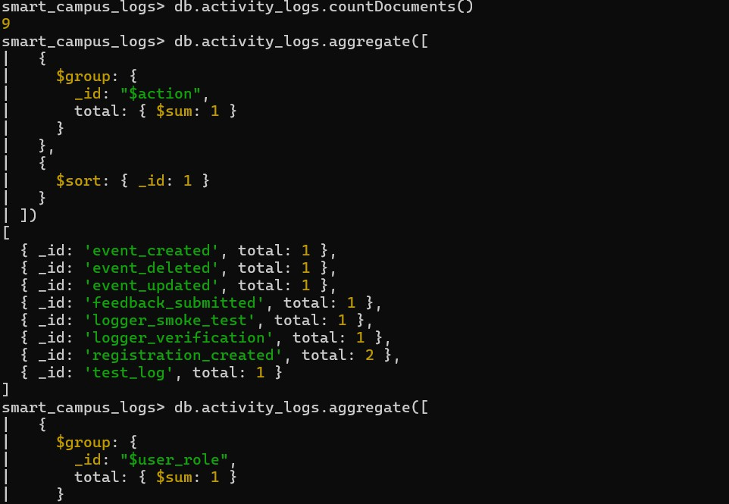
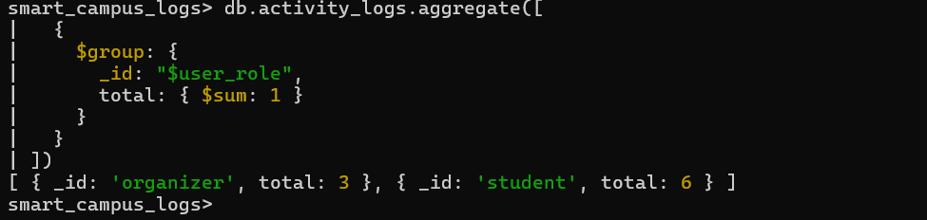

ADVANCED SQL FEATURES
The Smart Campus Event Management System uses advanced SQL features to improve data retrieval, simplify database operations and enforce business rules. The advanced SQL implementation includes views, stored functions, stored procedures and triggers.
These features are implemented in the dbms_features.sql file and were executed and verified in the MySQL database smartcampuseventmanagement.

Views
Views are virtual tables created using SQL queries. They simplify data retrieval by combining information from multiple tables and presenting it in a structured format.
The following views are implemented in the project:
- vw_event_details – provides a consolidated view of event-related information.
- vw_registration_details – provides a consolidated view of registration-related information.
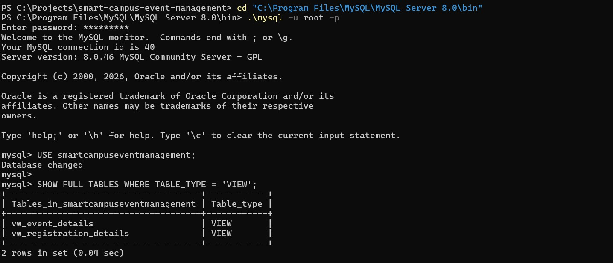

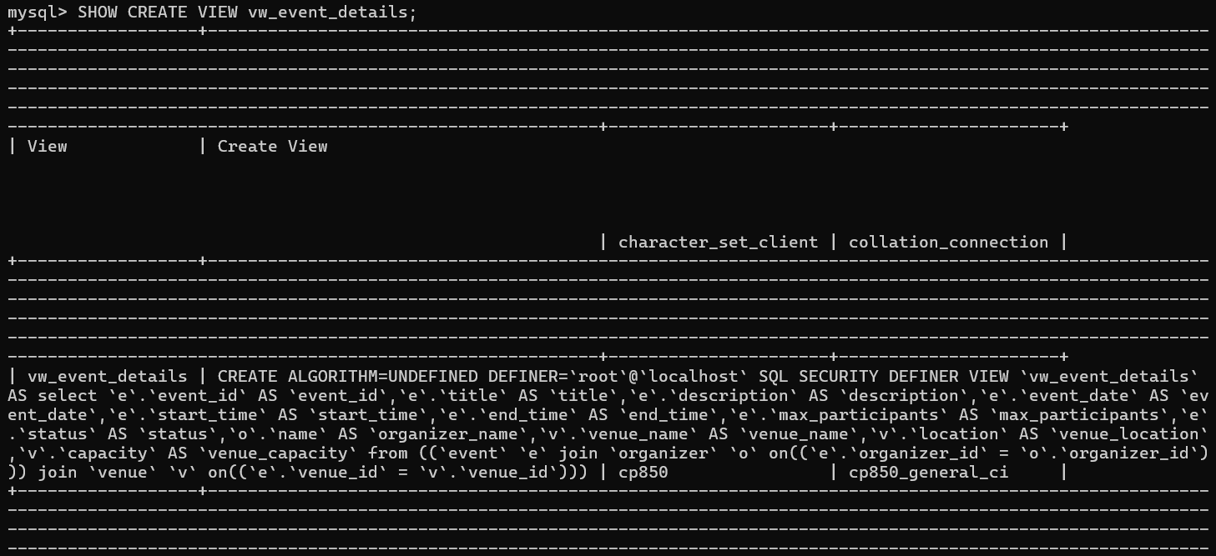
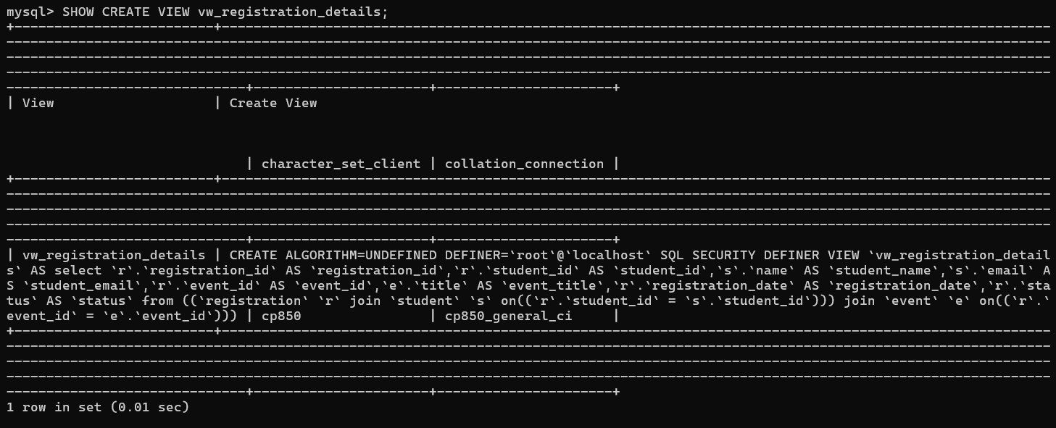
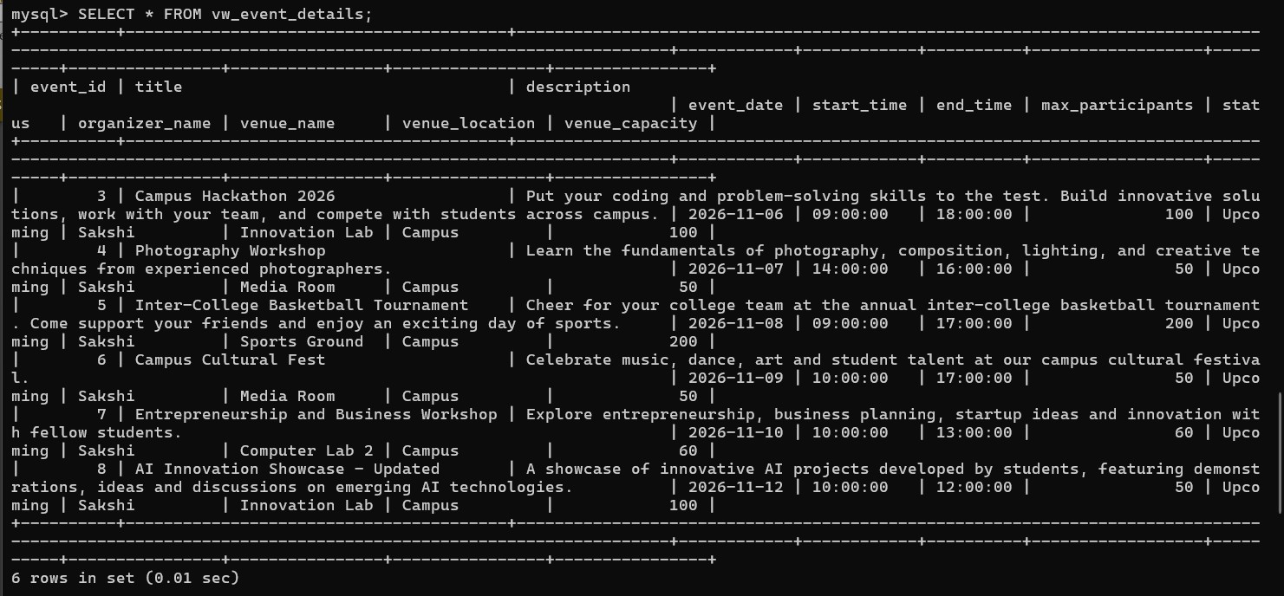

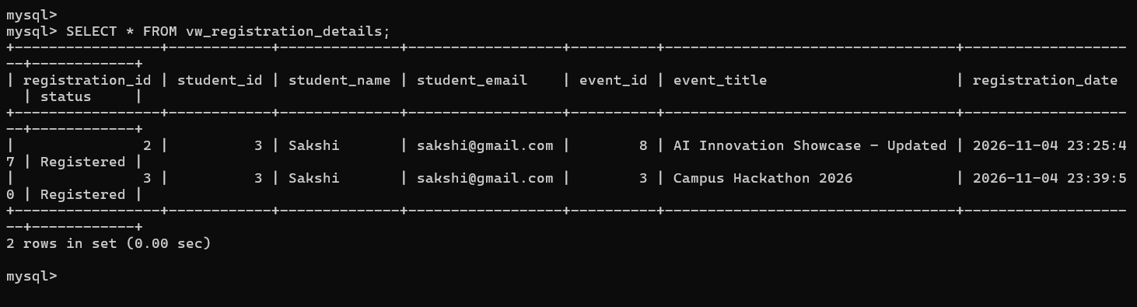

Functions and Stored Procedures
Stored functions and stored procedures are used to encapsulate reusable database operations. The project implements two stored functions:
      - fn_event_registration_count – retrieves the registration count associated with an event.
      - fn_available_seats – calculates the available seats for an event. The project also implements two stored procedures:
      - sp_get_event_registrations – retrieves registration information associated with an event.
      - sp_get_event_summary – retrieves a summary of event-related information.
These database routines reduce repeated SQL logic and make database operations easier to maintain.
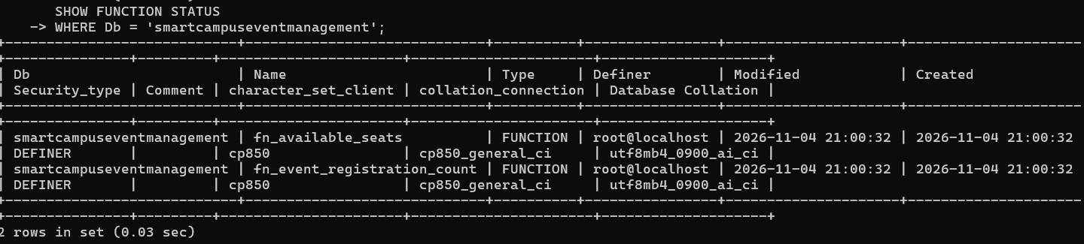
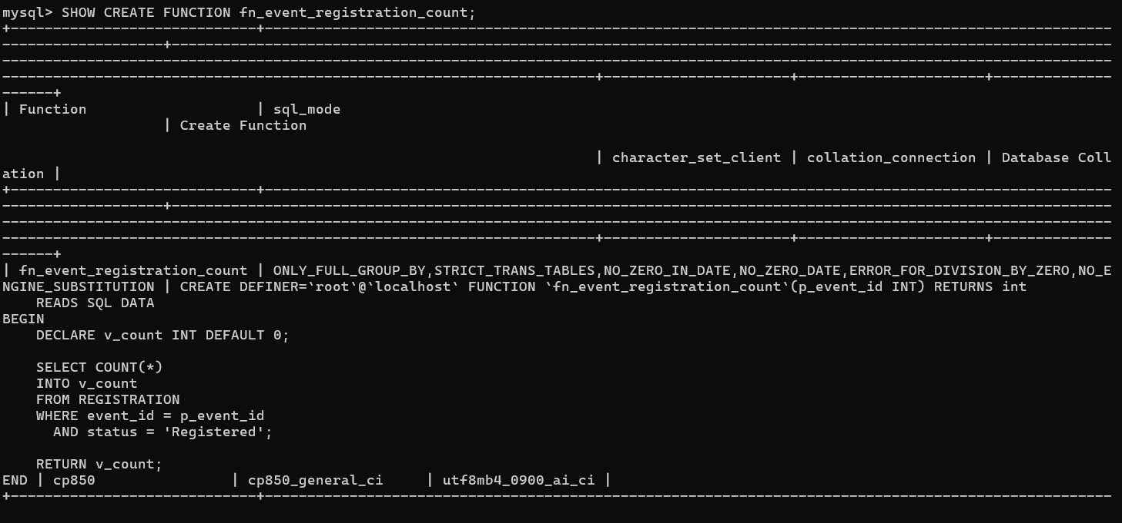

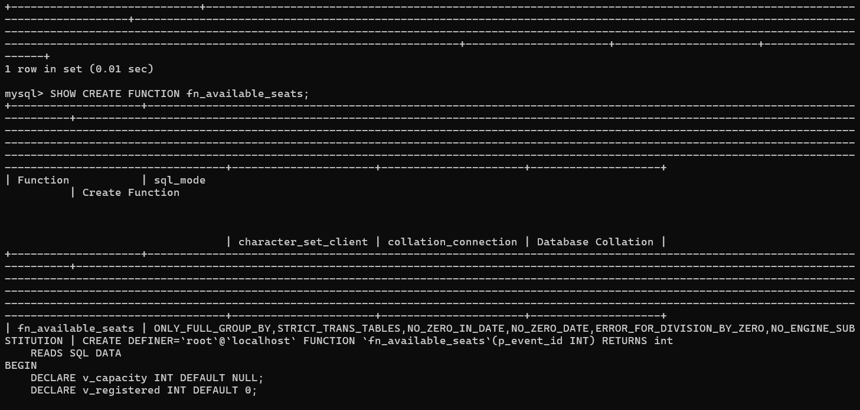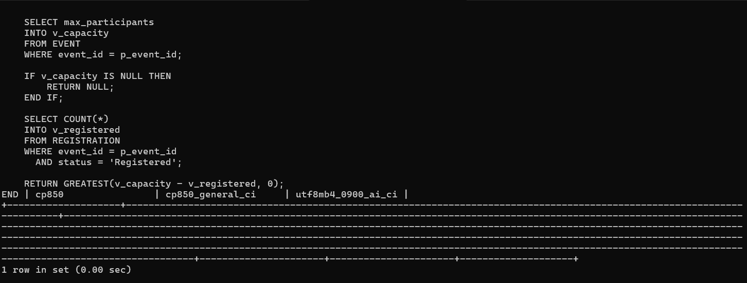

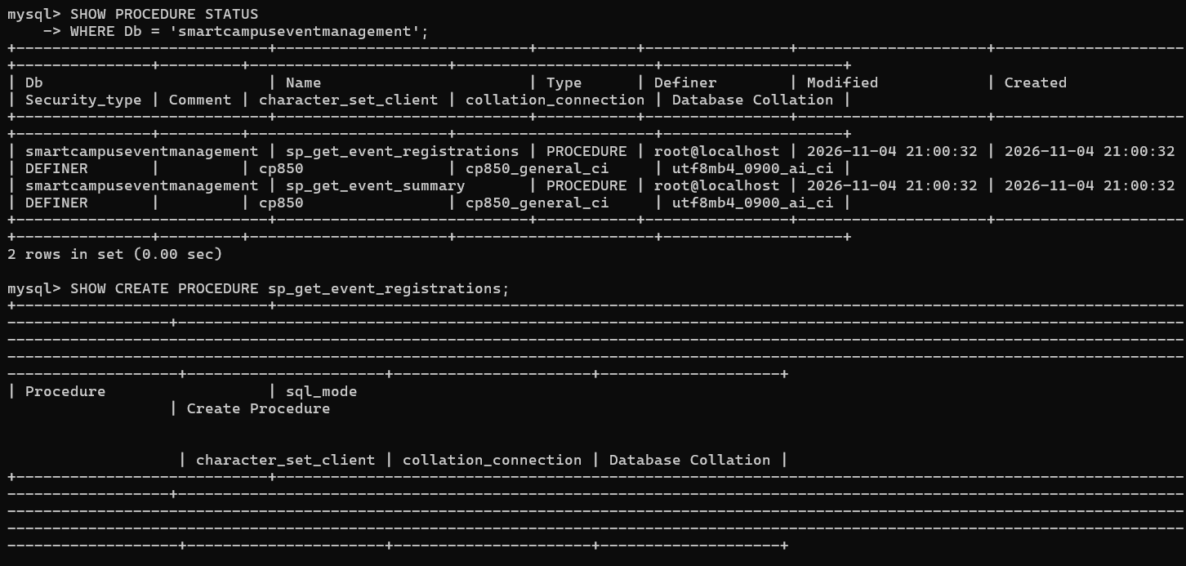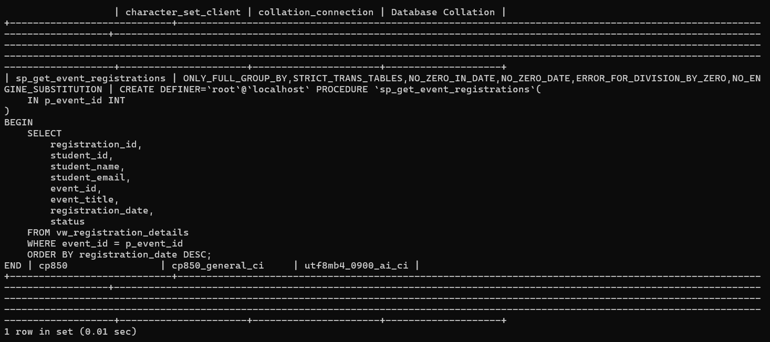
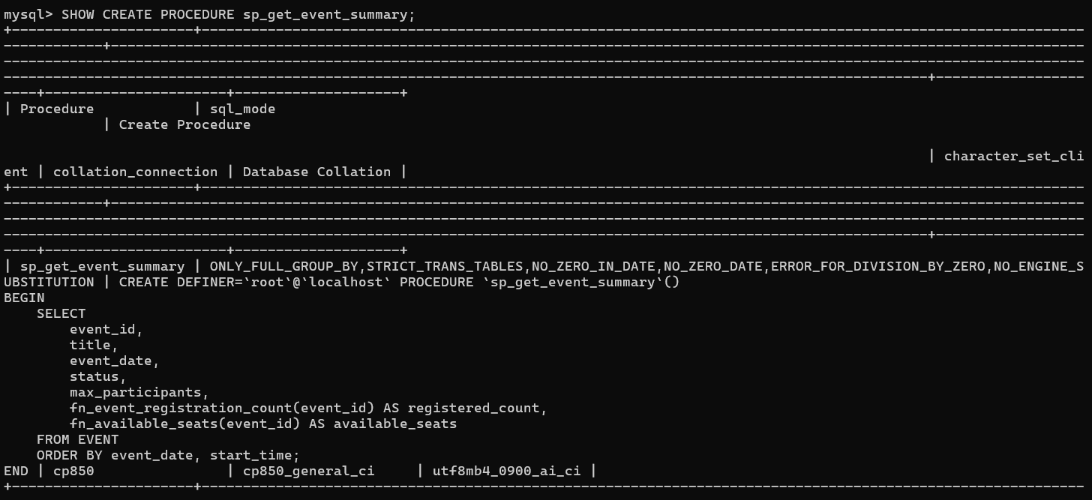

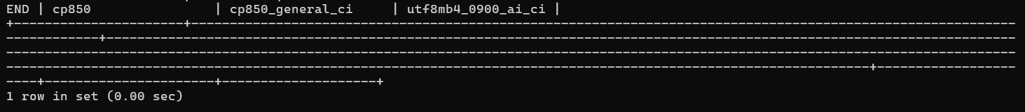

Triggers
Triggers are database objects that execute automatically when specified database events occur. They are used to enforce business rules and maintain data consistency.
The project implements two triggers:
- trg_check_registration_capacity – prevents a registration when the event has reached its maximum registration capacity.
- trg_check_event_capacity_update – prevents an event's capacity from being reduced below the number of existing registrations.
These triggers enforce capacity-related constraints directly at the database level.
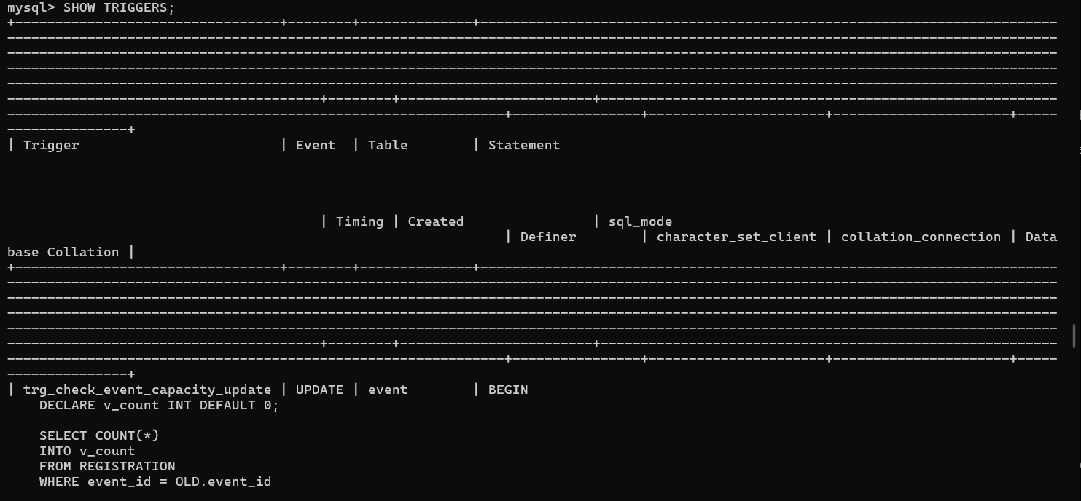

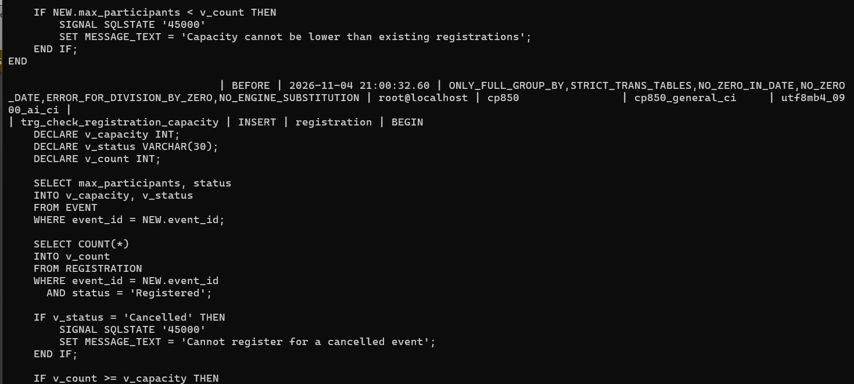
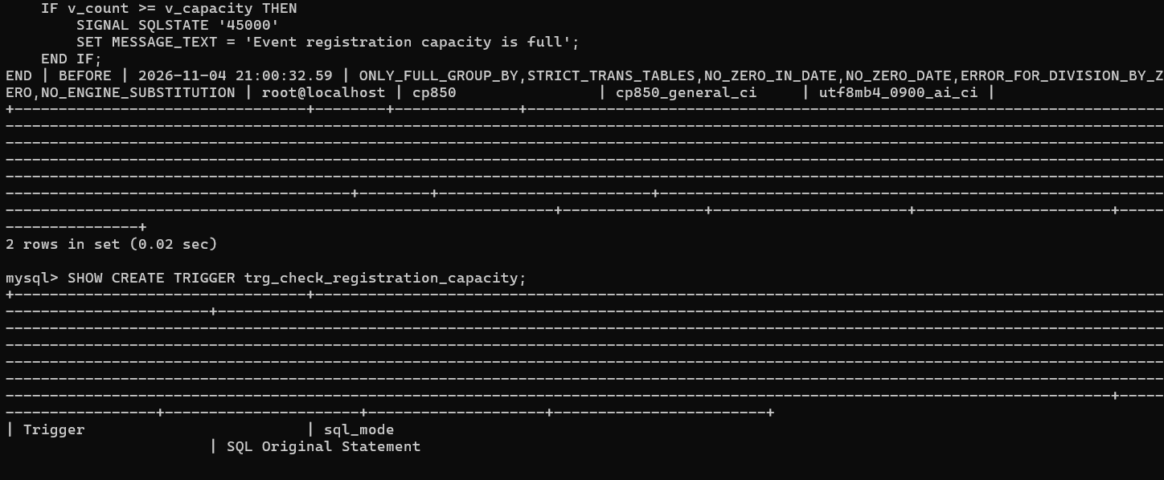
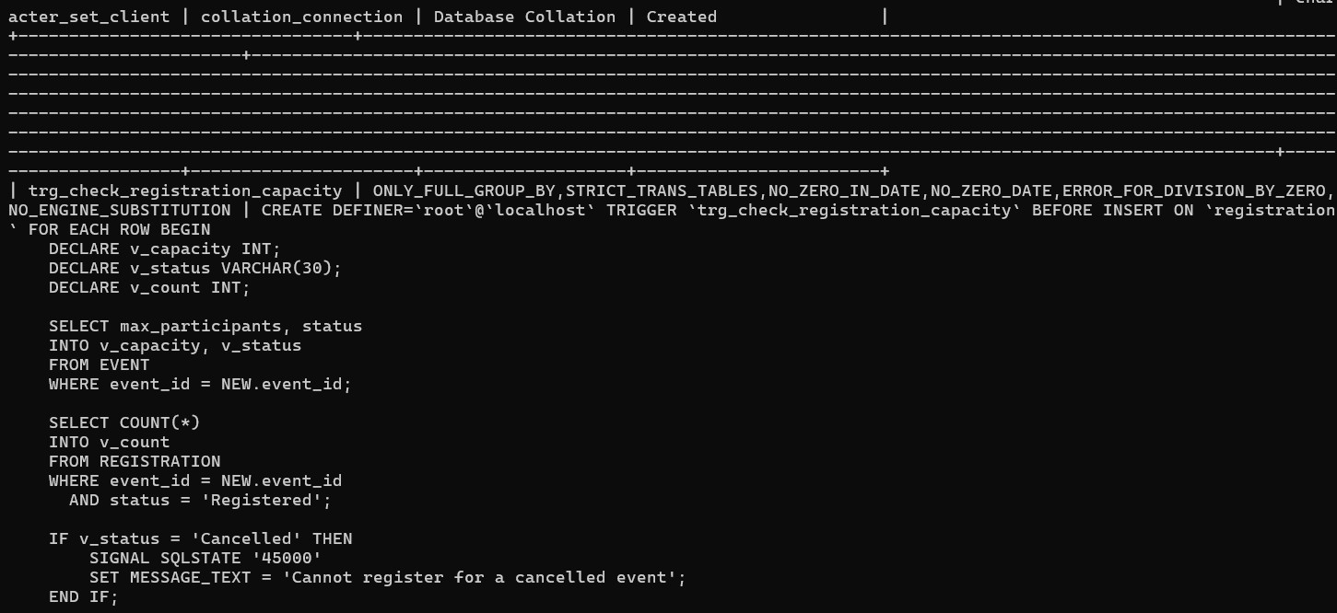

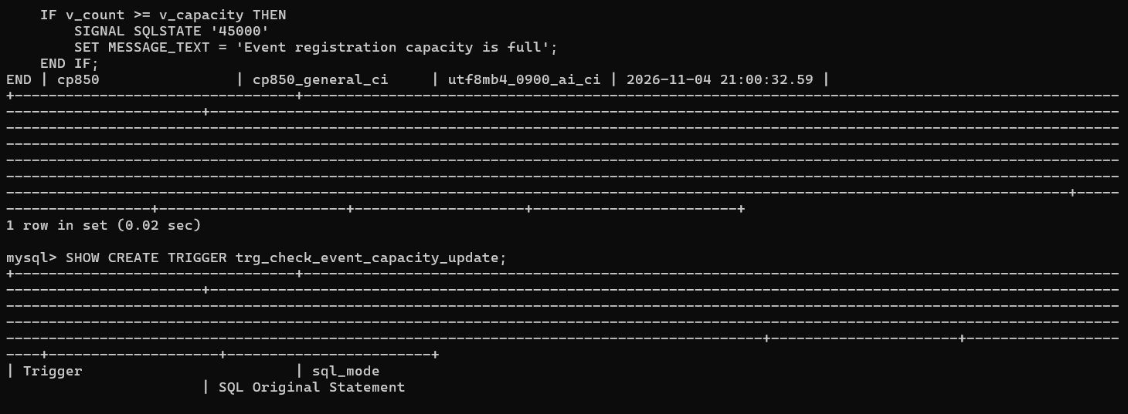
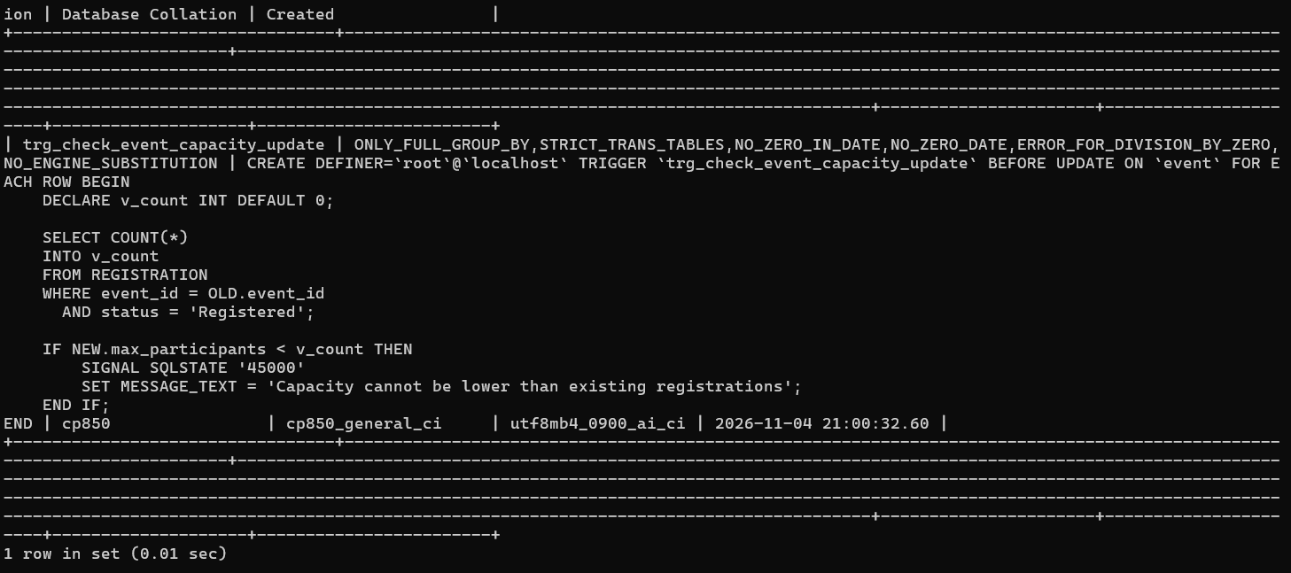

Indexes
Indexes are used to improve the performance of database queries by enabling faster access to records. The project database contains indexes on its relational tables to support data retrieval and relationship-based queries.
The indexes can be inspected using MySQL's SHOW INDEX command.
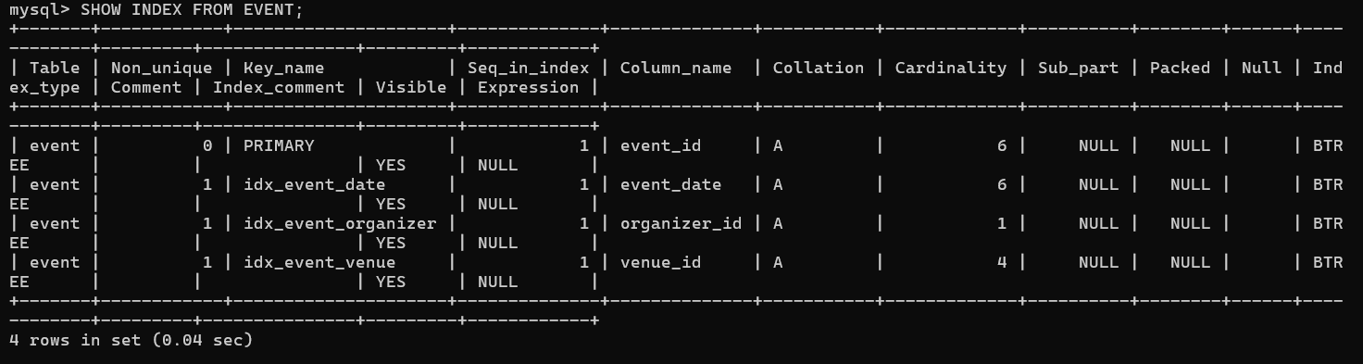

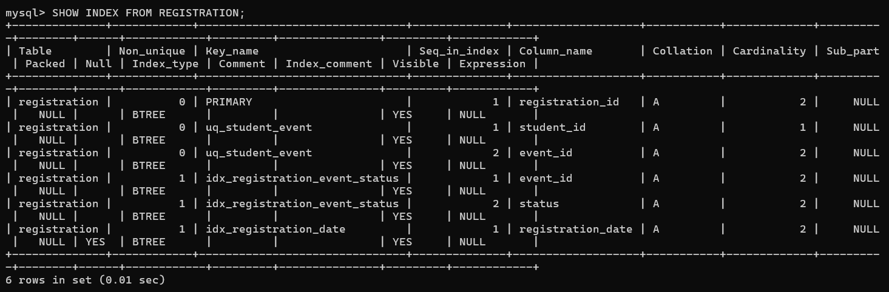
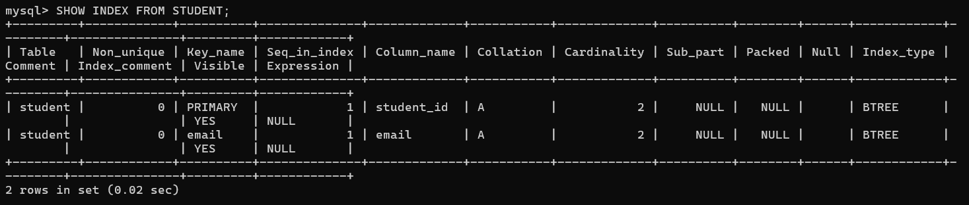
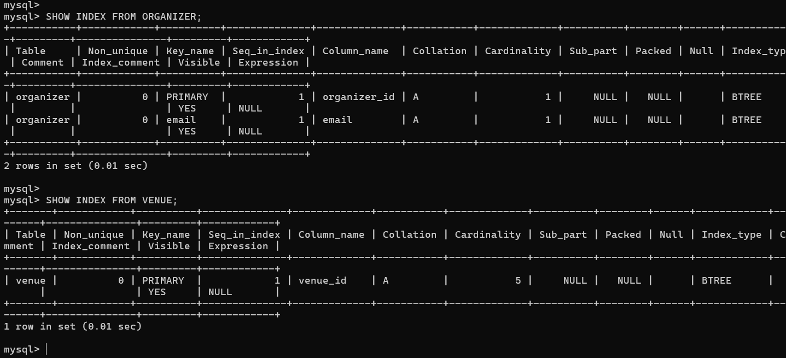

ORGANIZER FEATURES AND INTERFACE
The organizer module of the Smart Campus Event Management System provides an interface for managing campus events and monitoring event-related activities.
The organizer dashboard displays information such as the total number of events and upcoming events. Organizers can create new events, view their events, update event details and delete events.
The backend is integrated with the MySQL database to manage event information and related records. MongoDB is also integrated to maintain activity logs for operations such as event creation, updating and deletion.
The application includes validation to prevent event capacity from being reduced below existing registrations and to prevent deletion of events that have associated registrations or feedback.

TEAM CONTRIBUTION SUMMARY

Student | Primary Work Areas | Evidence / Files
POOJA KOPPAD | MySQL database implementation and management; advanced SQL features including views, stored functions, stored procedures and triggers; MongoDB activity logging implementation and database integration; database testing and verification; organizer-side feature integration and workflow testing. | dbms_features.sql; backend/src/config/mongo.js; backend/src/utils/activityLogger.js; MySQL database objects and query outputs; MongoDB activity log records; organizer dashboard screenshots; Git commits.
PRARTHANA HERUR | PostgreSQL database setup and MySQL-to-PostgreSQL migration; Prisma schema configuration and migrations; backend API development using Node.js and Express; authentication, event management, venue, registration and feedback APIs; frontend integration using Next.js and TypeScript; MongoDB setup and activity logging; application testing and debugging. | backend/prisma/schema.prisma; backend/prisma/migrations/; backend/scripts/migrate-mysql-to-postgres.js; backend/src/config/db.js; backend/src/config/mongo.js; backend/src/utils/activityLogger.js; backend/src/routes/; backend/src/server.js; frontend/src/app/; Git commits; application screenshots.

APPLICATION WORKFLOW AND SCREENSHOTS
The following selected screenshots demonstrate the implemented application interface. Only a small set of representative screenshots is included; the report does not require a screenshot of every page or every line of code.

Public events page
The events page presents the available campus events to users. It is backed by the public events API and displays event information retrieved from PostgreSQL.
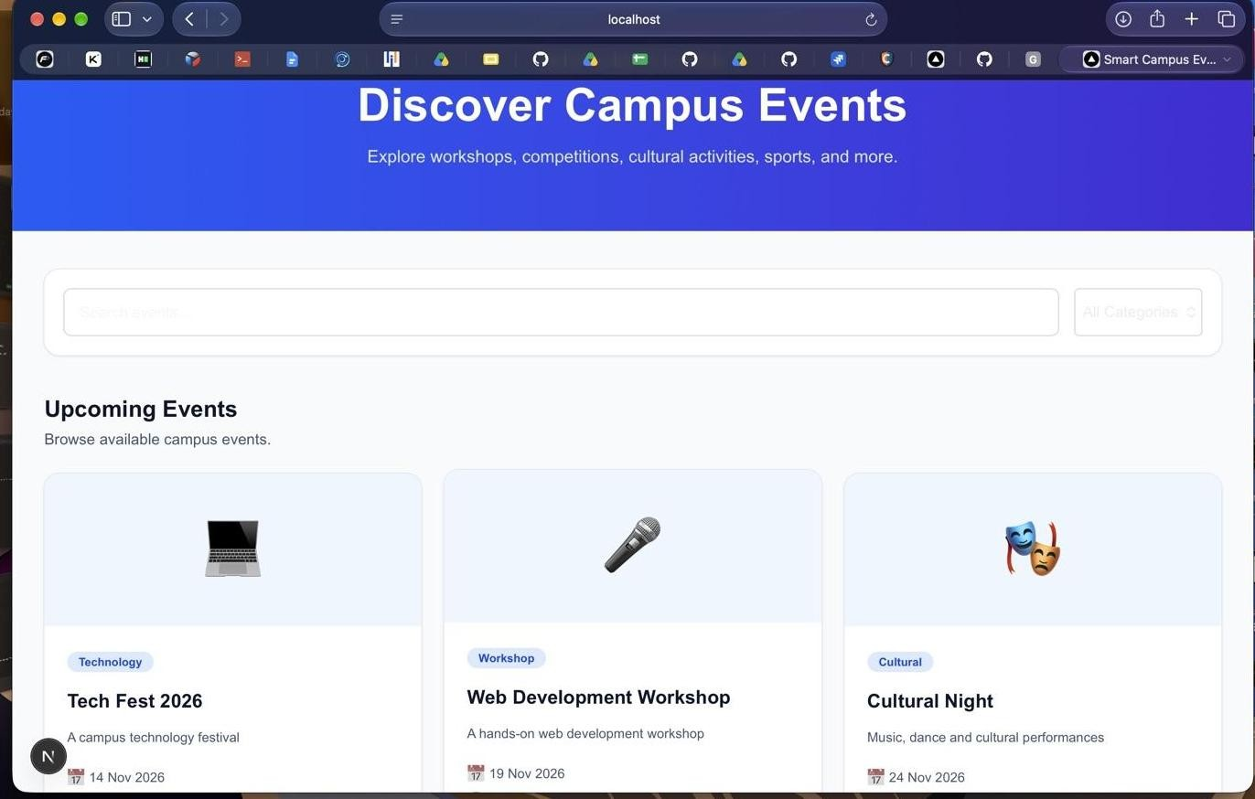
Figure 8.1: Public campus events listing.

Organizer dashboard
The organizer dashboard shows events associated with the authenticated organizer and provides access to event creation. Registration counts are displayed for the organizer's events.
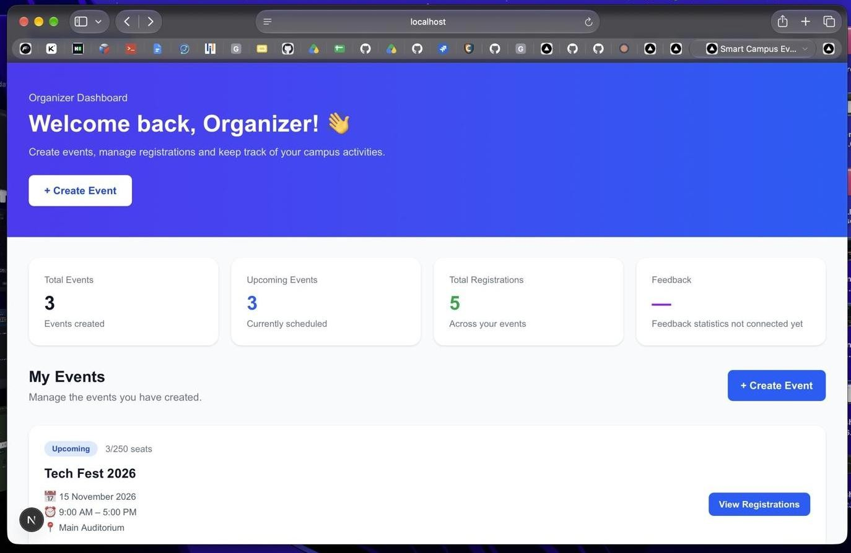
Figure 8.2: Organizer dashboard with organizer-owned events.

Create event form
The Create Event form collects the information required to create a new event, including title, description, date, time, venue, and participant limit.
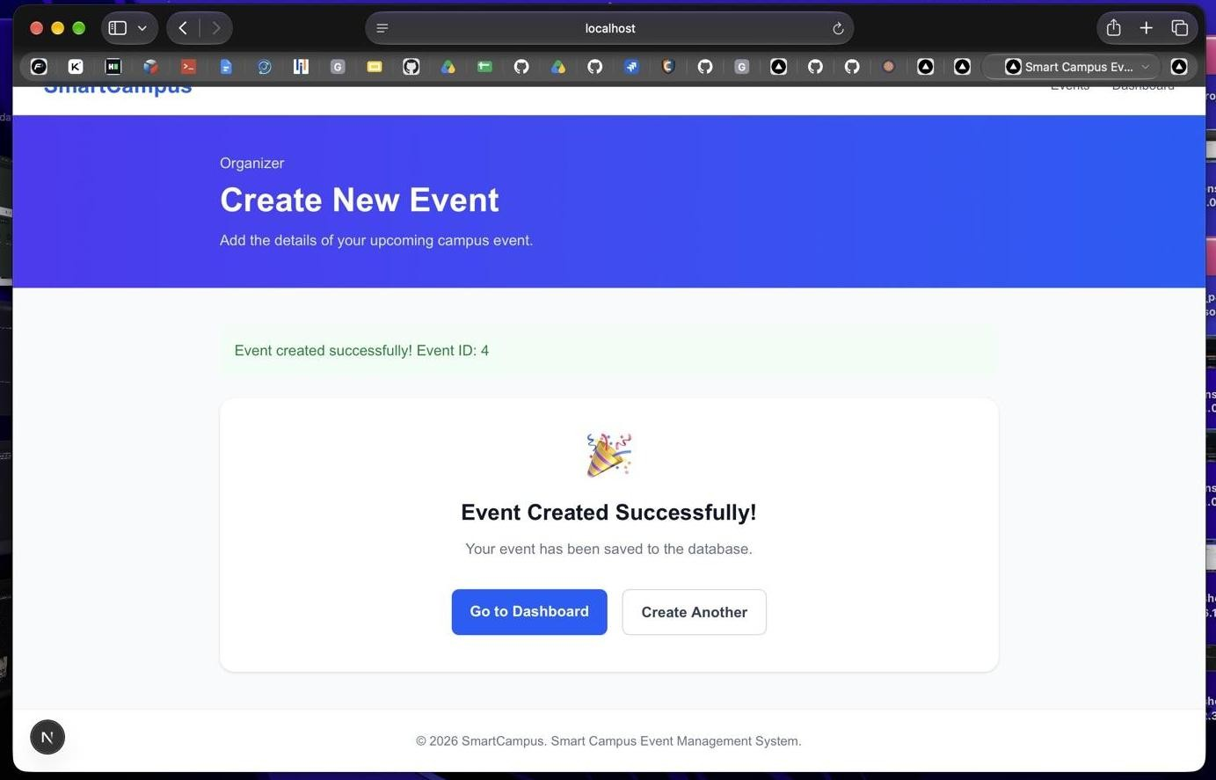
Figure 8.3: Create Event page.

Student registrations
The My Registrations page displays the registrations associated with the signed-in student.

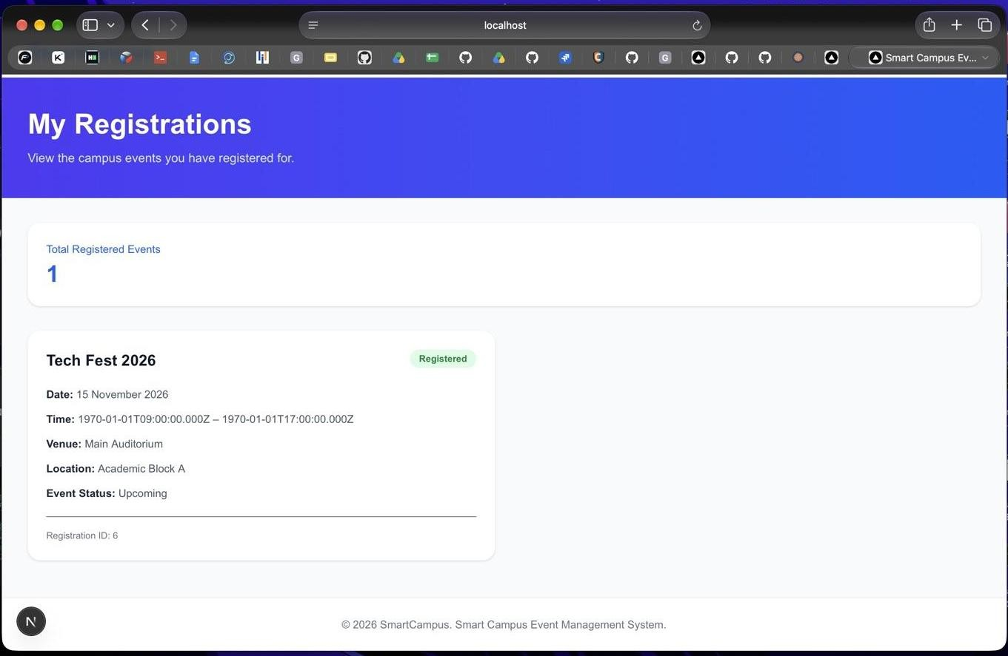
Figure 8.4: Student My Registrations page.

Feedback form
The feedback page allows a student to select an event, provide a rating, and enter comments.

Backend code evidence
For code-level evidence, include one screenshot of the backend route or Prisma schema in the code editor. The most useful evidence is the registration route showing the transaction and capacity/duplicate checks, or the Prisma schema showing the relational models and table mappings.

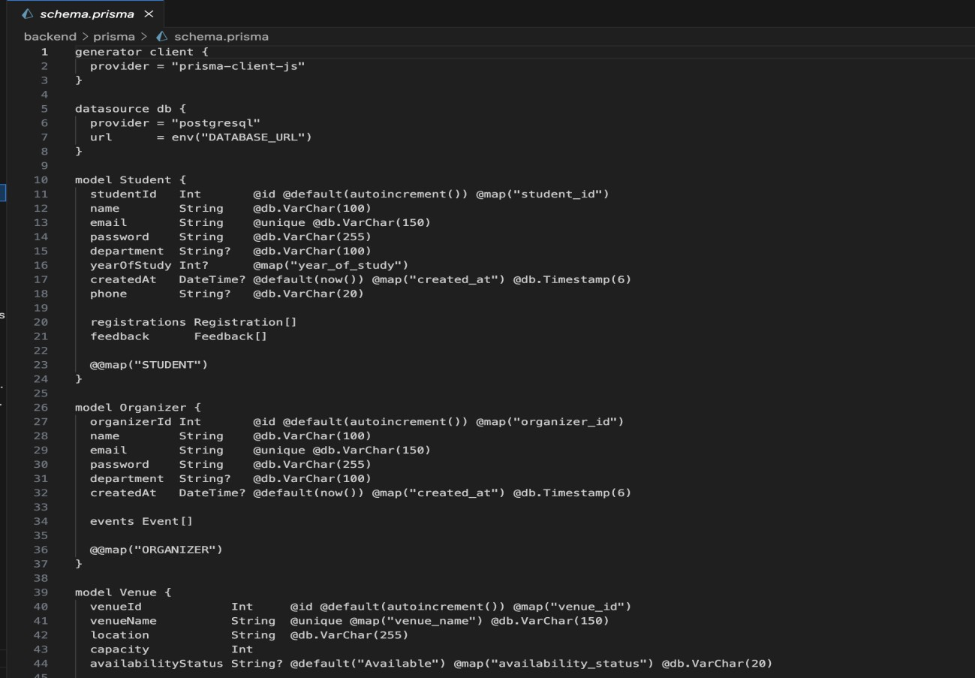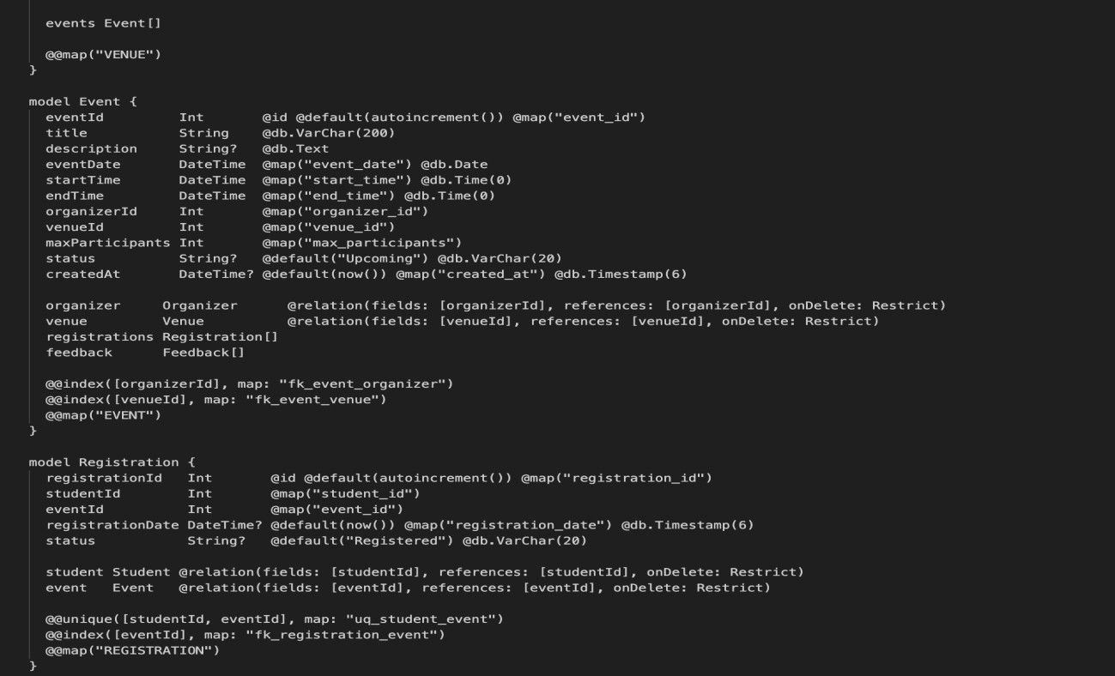

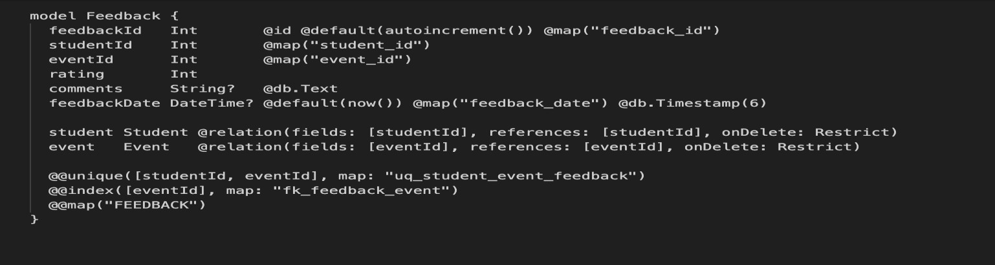

EVALUATION RUBRICS – COMPLETION STATUS
The table below records the implementation status of the project features covered in this report. It intentionally lists only completed and verified work; functionality that has not been completed or verified is not represented as implemented.

Evaluation area | Completion status | Evidence / remarks
Relational database design | Completed | ER diagram and relational schema prepared by the team.
MySQL source database | Completed | Original database retained with six  project tables and sample records.
MySQL to PostgreSQL migration | Completed | Migration script executed; 21 records across six tables verified in both databases.
PostgreSQL configuration | Completed | PostgreSQL 17.11 database and application role configured.
Prisma ORM integration | Completed | Prisma schema formatted and validated; initial migration applied.
Student authentication | Completed | Student registration and login tested; bcrypt password hashing and JWT authentication implemented.
Organizer authentication | Completed | Organizer login tested.
Public event listing | Completed | Events API and frontend event listing integrated.
Venue retrieval | Completed | Venue API returned the three seeded venue records.
Organizer event creation | Completed | New event creation tested; DBMS Testing Workshop created as Event ID 4.
Student event registration | Implemented and tested | Capacity and duplicate checks implemented in a database  transaction.
Student registration history | Completed | My Registrations page integrated with the student registration API.
Feedback submission and listing | Implemented | Feedback API and frontend pages integrated.
Frontend type checking | Passed | TypeScript check completed successfully after frontend integration.

Demonstrated test data
The database initially contained three events: Tech Fest 2026, Web Development Workshop, and Cultural Night. A further test event, DBMS Testing Workshop, was created through the organizer interface with

Event ID 4, a date of 10 December 2026, Seminar Hall as the venue, and a maximum capacity of 50 participants. The organizer dashboard displayed the new event with zero registrations out of the configured capacity.

Conclusion
The Smart Campus Event Management System demonstrates an integrated full-stack application supported by a relational database. The completed work includes MySQL-to-PostgreSQL data migration, Prisma-based database access, REST API development, JWT authentication, role-based route protection, student registration workflows, organizer event creation, and frontend integration. The project provides a foundation for managing campus events through a single web interface and demonstrates the practical application of DBMS concepts in a working software system.

REFERENCES
- PostgreSQL Global Development Group, “PostgreSQL Documentation.” https://www.postgresql.org/docs/
- Prisma, “Prisma ORM Documentation.” https://www.prisma.io/docs/
- Node.js, “Node.js Documentation.” https://nodejs.org/docs/
- Express.js, “Express Documentation.” https://expressjs.com/
- Next.js, “Next.js Documentation.” https://nextjs.org/docs
- React, “React Documentation.” https://react.dev/
- JSON Web Tokens, “Introduction to JSON Web Tokens.” https://jwt.io/introduction
- bcrypt, “bcrypt npm package documentation.” https://www.npmjs.com/package/bcrypt
- MySQL, “MySQL 8.0 Reference Manual.” https://dev.mysql.com/doc/refman/8.0/en/

APPENDIX – PROJECT REPOSITORY
The source code is maintained in the team's GitHub repository: https://github.com/poojakoppad04/smart-campus-event-management
The repository contains separate frontend and backend applications. The frontend contains the Next.js application routes and UI; the backend contains the Express server, route modules, Prisma schema, migration files, and MySQL-to-PostgreSQL migration script.

